Designer Babies ... Is the World Ready?

You finally meet the love of your life. You marry. After a couple of years, you give birth to an apparently healthy baby boy. You couldn't be happier. Within a couple of months, though, something seems amiss in your son's development. You take him to a doctor, who diagnoses your sweet little boy with Tay-Sachs disease. Before his third birthday, your little boy dies.

Now, a few years later, you are ready to try to have children again but don't want to go through the pain of another Tay-Sachs experience. After your first child was diagnosed, you learned that any child you and your spouse conceive has a 25% chance of suffering from Tay-Sachs, so you consult a genetic counselor to see if there is any way to ensure that your next child is disease-free. The counselor tells you that there are new ways of screening for diseases before your child is born... and you could even choose your child's gender, eye color, and hair color.

This webquest explores the science of prenatal genetic testing and the ethical slippery slope that it presents.
- Is it ethical to fertilize a number of eggs using IVF technology, grow them for a few days, then choose the ones that have genes for good health (and maybe blue eyes and blond hair) for implantation?
- If you would have had the choice, would you have wanted your parents to have you genetically tested before birth, knowing that you might not exist today if they had?
- Would such genetic choice bring us closer to the world presented in the film "GATTACA"?

Come find out what science can do and consider if what can be done equals what should be done.
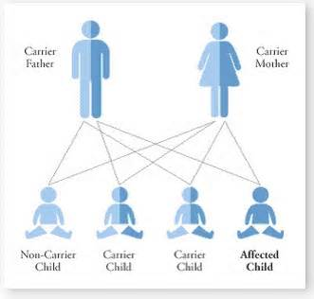

- Please vote in THIS POLL before beginning your project. Surprised at all by the results? EXPLAIN.

- Start by reading an article from the August 2014 edition of Popular Science magazine. The article is entitled, "Infant Possibilities": it provides a good overview of the possibilities that currently exist in embryonic selection.

- Choose ONE of the following roles:
- prospective parent
- genetic counselor
- genetic researcher
- medical doctor specializing in infertility treatments

Each role has specific websites to visit and questions to answer.

- Complete the PERSONAL REFLECTION form.

