To Clone Or Not To Clone?
Human cloning is such a hot and critical issue in today’s world that the questions raised about it cannot be answered by only one group of people (e.g. ethicists or scientists).

Step 1: Select your role and become specialized on the issue.
Scientist OR Ethicist

Step 2: Become an expert on your own area
SCIENTIST 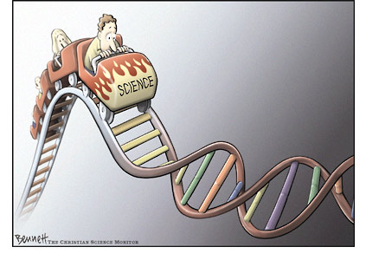
Your task is to collect, analyze and evaluate information to generate your own viewpoint and argument on whether or not humans should be cloned and why. To do this, you need to be prepared to answer such questions as the following to clarify and testify your argument:
1) What are the benefits of cloning?
2) What are the potential benefits of human cloning?
3) What are the risks of cloning?
4) What are the potential risks of human cloning?
5) Do the benefits outnumber the risks? Why?
6) What are the new research and experiments being done currently?

Here are some useful links for you:
http://www.guardian.co.uk/theissues/article/0,6512,533501,00.html
http://www.humancloning.org/
http://www.globalchange.com/What-is-Human-Cloning-How-to-Clone.-But-Ethical/
http://www.usatoday.com/educate/college/healthscience/articles/20030126.htm

ETHICIST
As an ethicist, your task is to explore, examine, and evaluate your findings on the issue and present your argument on whether or not humans should be cloned and why/why not. Get prepared to answer such questions as the following while you are doing your task:
1) What are the potential benefits of human cloning?
2) What are the potential risks of human cloning?
3) Do we need to clone humans? Why / Why not?
4) Who should decide to allow or ban human cloning?
5) What should be the ethical standards?

You might want to follow the links below to carry out your task:
https://www.geneticsandsociety.org/internal-content/reproductive-cloning-arguments-pro-and-con
http://www.nbcnews.com/id/3076915/
http://www.humancloning.org/
http://www.guardian.co.uk/theissues/article/0,6512,533501,00.html

