Societies Past #1

The Vikings of Greenland

Norse Vikings began settling in Greenland in A.D.
984. Excavations show that, at the time of their arrival, there were large expanses of forest, with birch trees up to 4-6 meters high and the hills were covered by grass and willow bushes.

Initially, the Vikings prospered, establishing two main settlements on the southern tip of the island. From the 400 or so of farms, whose stone ruins can still be seen, archaeologists estimate that the Viking population in Greenland may have risen to a height of about 5,000.

The Vikings herded various livestock, taking

Source: Google maps

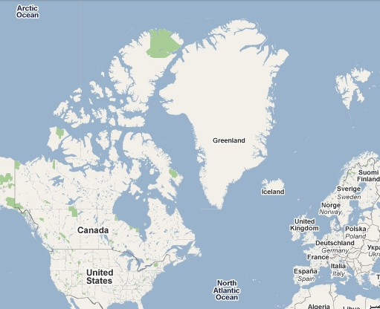Greenland
advantage of the countryside for grazing and growing enough hay in the summer to feed their animals during the winter months, and established dairy farms. They cut down small trees in order to build fires and produce charcoal.

Merchant ships from Iceland and Norway traveled to Greenland once or twice every year in order to trade. The Vikings were highly dependent upon European trading partners for iron (which they used wood-fed fires to forge into tools and weapons), wood (for boat building), supplemental foods, and social contacts. In exchange, they hunted walruses, narwhals and polar bears in order to trade with Europe.

They also traded with the Inuit, who, having reached the northern part of the island around A.D. 1000, first came into contact with the Vikings in the 12th century. Relations between the Vikings and the Inuit seem to have been friendly at times, and downright hostile at others. Prior to the arrival of the Inuit, the Vikings had had the island, its waters, and its resources to themselves. After the arrival of the Inuit, the Vikings found themselves competing for hunting territory and other resources.

What do you think happened to the Vikings of Greenland?

Societies Past #2

The Easter Islanders

Easter Island, also known as Rapa Nui, is tiny island in the Southern Pacific Ocean formed by a series of major volcanic eruptions. It lies
3,200 km west of the coast of Chile and around 2,100 km from the nearest Polynesian island. It is so remote that, after it was settled by seafaring Polynesians around A.D.
800, no one else landed there until Europeans arrived on Easter Sunday in 1722.

Source: Google maps

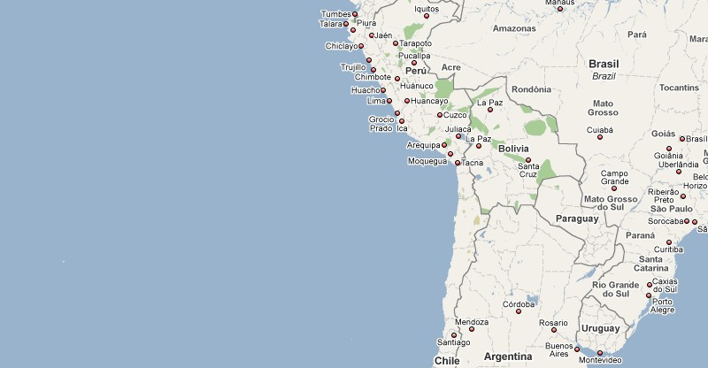Easter Island

When the Polynesians arrived at Easter Island, it was covered by a lush tropical forest that included the world's largest palm tree and dandelions of tree height, despite a dry climate and only 100 cm of rain per year. The Polynesian settlers used the island’s trees for firewood, to make room for gardens, to build canoes and buildings, and to obtain logs to use as rollers and levers to raise giant statues, called
moai. Carved out of volcanic rock, moai were created as testaments to deceased ancestors and may also have been used to pay respects to powerful chiefs. A total of 887 moai have been found across the island. Weighing up to 80,000 kg, they were transported and raised vertically onto platforms without any animals and pulleys. Only tree trunks and human muscle power were used as tools.

The island was also home to at least 6 species of land birds and 37 species of breeding sea-birds, the largest collection of breeding sea-birds anywhere in the Pacific. The Polynesians hunted both the land birds and the sea-birds, and also used their canoes to catch porpoises and tuna. They also harvested the island’s plants and fruits.

The ample resources provided by the island allowed the population to flourish to an estimated 10,000 people by A.D. 1550, with distinct clans and population centers forming around the island as its population grew.

What do you think happened to the Easter Islanders?

Societies Past #3

The Anasazi
In what is now the American southwest, the Anasazi (a Navajo word meaning "ancient ones" or possibly "ancient enemies") built dramatic adobe dwellings, or pueblos. Remains of buildings up to 6 stories tall, with up to 600 rooms, can still be found in the four corner areas of Arizona, New Mexico, Colorado and Utah that on the heart of what once was Anasazi territory. Chaco Canyon was the hub of Anasazi civilization, with its numerous large pueblos serving as administrative and ceremonial centers for a widespread population.

The expansion of the Anasazi civilization began around A.D. 600, with the arrival of corn, squash and bean crops from Mexico. It was at this time that Anansazi in Chaco Canyon and other settlements abandoned hunting and gathering in favor of cultivating these newly arrived crops.

The Anasazi demonstrated considerable ingenuity when it came to surviving in the dry American southwest, with its unpredictable rainfall and nutrient-poor soil. In order to grow their crops, the Anasazi hoarded rainwater and used it both sparingly and effectively. Evidence of dams, canals, and other water control features found by archaeologists demonstrates the degree to which water was valued by the Anasazi people. In some areas, irrigation agriculture was used to carefully channel water to flood out over the fields. Because of their ability to feed themselves through agriculture, the Anasazi population expanded. They cut down trees for construction and firewood.

Archaeological evidence demonstrates that the Anasazi tended to abandon their sites after a few decades and relocate. This meant that the population became spread over a wide area.

What do you think happened to the Anasazi?
