Phoenix Jang
(Background) 19th century China
- Hung Xiuquan- Son of a farmer, inspiring Chinese bureaucrat, under Southern Chinese Christian influence, went to found the Heavenly Kingdom on earth. Named himself the younger brother of Jesus.
- 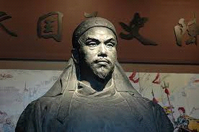Qing faced dry seasons, famines, and floods. The government did little to relieve the people. The economy was failing, the coasts taken over by the Western powers, and anti-Manchu's were starting to rise.
- 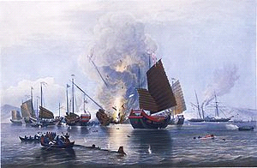Defeat of China in the first Opium war left the country split and in tatters.
- Secret groups, such as the Taiping, already existed from the first emperor. These declines in the country made them act, such as taking ports and executing Manchurian officials.
- Hung failed to pass the exams to become an elite, which probably made him even more hostile towards the Manchus. He turned to politics after his conversion to Christianity.
- Became ill, but had a vision that he was the younger brother of Jesus, thus starting his ambition. Used Christian doctrines and Confucianism to create his own doctrine.
- With the depression of the Qing Dynasty, Hung's doctrine and the decline of China gathered the peasants and sparked the Taiping Rebellion.
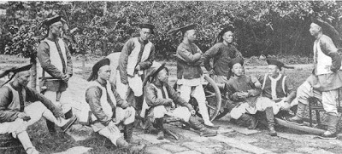
(The Rebellion)
- The Opium war and the population's addiction angered the Taiping. They believed that the Qing dynasty was at fault for turning silver into compressed Opium balls.
- The first uprising was in Jintian, but was exterminated by the government. However, the people did not take this lightly, and formed a 10 000 strong army and retook Jintian.
- Hung took this as an opportunity and announced the new creation of the Heavenly Kingdom of Taiping.
- He set rules, such as none are allowed to live together or have intercourse. Men and women were segregated but were equal. However, he allowed himself to indulge in mutiple women.
- Foot binding was banned, used a lunar calender, and banned opium, prostitution and other immoralities. Private land owning was also banned, and land was distributed equally.
- 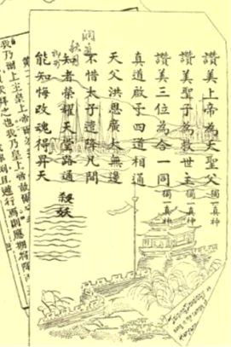The Kingdom had "The Land System of the Heavenly Kingdom" which described how much catties of grain were to be produced, how much distributed, how much land was to be given to a family, and how many soldiers each area was supposed to produce.
- The Taiping Rebellion was inconsistent in its military successes, and ultimately collapsed from internal affairs, defeats from better equipped Qing and European armies, and the death of Hung from food poisoning.
- In the end, over 20 million, and even closer to 30 million had died throughout the 14 years of carnage.
(Western)
- The Western powers, USA, and Japan all looked for an opening to get profit and power. With China weakened, the powers decided to support the weak Qing government to stop any oppositions. When the powers took over, they colonized it and made the "open door" policy, where all countries had equal responsibilities.
- 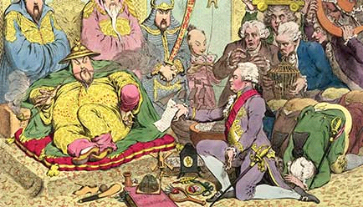The British introduced Opium and traded it for tea and silver. They established the East India Company, and saved Britain from losing its power. America traded away its surpluses that was destroying its economy.

