Comparing World Revolutions Research Activity

Instructions: Please follow closely!

Step 1: Research for Knowledge & Understanding
For each of the World Revolutions that we have discussed in this class (American, French, Haitian, & Latin American) answer the basic question sets below. You may answer these in bullet point list. (Note: There are 7 question sets with multiple questions in each set… make sure you address them all!)
- How was Enlightenment thought a factor in the Revolution?
  - What Enlightenment thinker’s thoughts can be most seen in the revolution? What Enlightenment principles can clearly be identified as causes for revolution?
- Who Revolted?
  - Who Revolted? What did most of the people who came together to revolt have in common? Class or caste? Race or ethnicity? Religion? Political affiliation? Type of job? Or was it the people as a whole?
- Why did they revolt?
  - Why did they revolt? Why were people unhappy with their government? Why did they believe that revolution was the only way to make the change that they wanted?
- How did they organize?
  - How did they organize? Was the revolution planned for a long time? Was it spontaneous? How did people find out about the revolution? Were there leaders who did the organizing?
- How did the people overthrow the government?
  - How did the people overthrow the government? Did they take over government buildings? Did they assassinate leaders? Did they engage in peaceful demonstrations? Did they have the support of the military? Did they engage in acts of warfare?
- How did the government respond?
  - How did the government respond? Did leaders peacefully give in to the people’s demands? If so, how long did it take for them to give in? Did they fight back using military force?
- How was the government the same or different following the revolution?
  - How was the government the same or different following the revolution? What type of government emerged after the revolution? Why?

Step 2: Select THREE World Revolutions to compare and contrast by evaluating their success or failure.
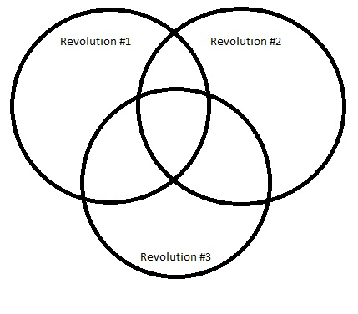
- Draw a vin-diagram chart for the CAUSES of the revolutions with similarities and then create a second, separate vin-diagram chart for the IMPACTS of the revolutions. (See example below.)
Causes or Impacts of Revolution #3 go here.

Similarities or differences for all revolutions causes or impacts go here.
Causes or Impacts of Revolution #1 go here.
Causes or Impacts of Revolution #2 go here.

Rev.1 & Rev.2 go here.
Similarities or differences for Rev.2 & Rev.3 go here.
Similarities or differences for Rev.1 & Rev.3 go here.
Step 3: Summative Writing
- Using the knowledge and understandings gained through your research and conversations we’ve had in class, you are to write a brief summary that takes a position on which World Revolution was most successful in terms of achieving the Revolution’s original goals, enacting Enlightenment thoughts and philosophies, and the Revolution’s impact on global affairs.

