**Careers in Psychology WebQuest**

http://psychology.massey.ac.nz/images/phrenology-b.gif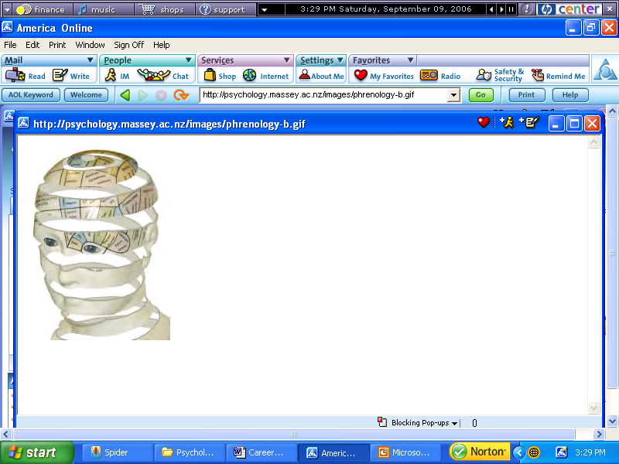[http://images.google.com/images?q=tbn:e15M7yIofZxrBM:http://psychology.massey.ac.nz/images/phrenology-b.gifhttp://images.google.com/images?q=tbn:e15M7yIofZxrBM:http://psychology.massey.ac.nz/images/phrenology-b.gif](http://images.google.com/imgres?imgurl=http://psychology.massey.ac.nz/images/phrenology-b.gif&imgrefurl=http://psychology.massey.ac.nz/&h=250&w=187&sz=25&hl=en&start=3&tbnid=e15M7yIofZxrBM:&tbnh=111&tbnw=83&prev=/images?q=psychology&svnum=10&hl=en&lr=&ie=UTF-8)



**Do you suffer from:**

***friggatriskaidekaphobia***

**OR**

[***paraskevidekatriaphobia***](http://en.wikipedia.org/wiki/Paraskevidekatriaphobia)

**Introduction:**

**There are literally hundreds, maybe even thousands, of jobs within the field of Psychology and new ones are being created every day**

**How do you figure out which careers you might like to try? It takes some thought, creativity, and research. In the following exercise you will have the opportunity to learn about yourself and careers found within the psychology field.**

**Begin by reading through the components of the WebQuest to see what will be required.**

**The Task:**

1. **You will research a career in a specialized area of psychology and**
2. **Write a profile/presentation on this area in format of your choice 🡪 document/ppt/video.**

**Choose one career in psychology that you want to learn more about. Some examples include:**

* **Sports psychology**
* **Clinical psychology**
* **Neuropsychology**
* **Forensic psychology**
* **Educational psychology**
* **Community psychology**
* **Industrial/organizational psychology**

**This list is not exclusive; there are many other specialties you can investigate.**

**For the career you have selected, find the answers to the questions on the Careers Worksheet.**

**Then use the information you have gleaned to create a presentation designed to inform prospective psychology majors about a career in the specialty.**

***The presentation should be creative, attractive and factual. It should be designed to not only inform, but also to “sell” the career.***

**The Resources:**

**Go to** [**Careers in Psychology**](http://www.apa.org/careers/resources/guides/careers.aspx)**. This is the website of the APA. Start here and read about Careers for the 21st Century. There are many other websites you can use. Here are a few to get you started:**

[**Careers in the Field of Psychology**](https://careersinpsychology.org/psychology-careers/)[**A Guide to Careers in Psychology**](https://www.learnpsychology.org/psychology/)

[**Psychology Career Information**](https://www.psychologydegree411.com/careers/)[**14 Career Options for Psychology Majors**](https://www.psychologytoday.com/us/blog/beyond-the-psychology-major/201606/14-career-options-psychology-majors)

[**9 Highest Paying Psychology Careers**](https://www.verywellmind.com/the-9-highest-paying-psychology-careers-2794940)[**The 25 Most Lucrative Careers in Psychology**](https://www.bestpsychologydegrees.com/25-most-lucrative-careers-in-psychology/)

**What to Turn In:**

1. **Careers Worksheet with complete answers to the required questions.**
2. **A presentation designed to profile your chosen specialty for prospective psychology majors.**

**Good Luck on your Quest!**

