Creativity & Boredom Assignment
ARE YOU LOSING YOUR CREATIVITY? [Hopefully, No!]
Research has shown a direct correlation between cell phone use, boredom (or lack of it), and creativity. Use the following information to complete the questions on THE WORKSHEET posted online.

I. First, answer the brainstorming questions on your notes. These are personal reflection questions.

II. Now, look at the table below. Notice how the average minutes of cell phone use has changed in the past four years. Use your observations to answer the questions on your worksheet.
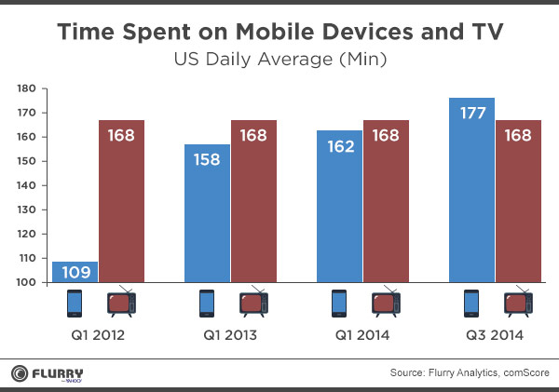

III. Now that you've reflected on how many minutes are spent using cell phones, let's look at HOW they're used. Watch the video – How Many People Can’t Walk Without Their Smartphone? – posted online (or get the file from me) and use your observations to answer the questions in your worksheet.
IV. Have you ever stopped to think not only how much time you spend on your cell phone, but also WHAT you are missing? You are the first generation to experience "constant contact"; you have technology at your fingertips 24/7. What is different about your generation? How will cell phones impact your future? What part of your mind is being replaced with cell phone use?
Read this article (you may also listen to the podcast. It's much better!) and answer the questions in your worksheet.
Bored ... And Brilliant? A Challenge To Disconnect From Your Phone

V. How important IS boredom? Read this study about just how important it is to be bored once in a while. Answer the questions in your worksheet.
Being Bored Can Fire Up Your Creativity

And last, but not least, read about the Bored and Brilliant campaign. Are you willing to install the Moment (iPhone) or BreakFree (Android) app? – Check it out under the “How It Works” section!

