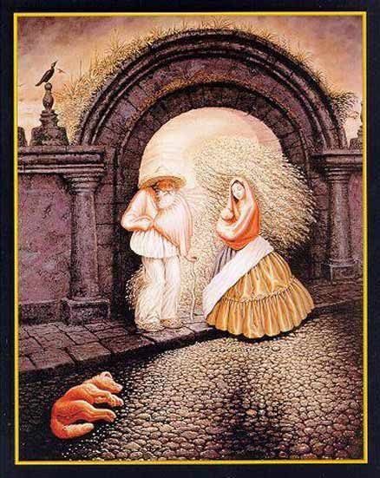

HOW OBSERVANT ARE YOU?
There are 9 people in this picture.
If you find 6, you have ordinary powers of observation
If you find 7, you have above average powers of observation.
If you find 8, you are very observant. Congratulate yourself.
If you find 9, you are extremely observant, very intuitive and creative. You can rival the observation powers of Sherlock Holmes!

P.S. – I DON’T have the answer – so I hope someone finds them all.

