Neurological Disorders Web Quest Project
Neurological disorders are diseases of the central and peripheral nervous system. In other words, the brain, spinal cord, cranial nerves, peripheral nerves, nerve roots, autonomic nervous system, neuromuscular junction, and muscles. These disorders include epilepsy, Alzheimer disease, Parkinson's disease and many others.
Mental disorders, on the other hand, are "psychiatric illnesses" or diseases which appear primarily as abnormalities of thought, feeling or behavior, producing either distress or impairment of function.
Hundreds of millions of people worldwide are affected by neurological disorders: For example, 50 million people have epilepsy; 62 million are affected by cerebro-vascular disease; 326 million people suffer from migraine; 24 million are affected by Alzheimer disease and other dementias globally.

TASK You will research a disorder or disease of the nervous system and present your findings in the form of a PowerPoint Presentation.

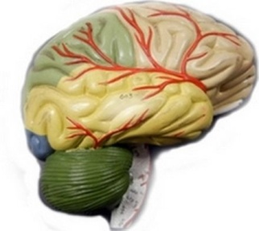

You may choose any of the following disorders. If a disorder is not on the list, check with Mr. Farshtey to see if it is appropriate.
- Alzheimer's Disease
- Asperger's Syndrome
- Attention Deficit Disorder
- Autism
- Bipolar Disorder
- Dissociative Disorder
- Depression
- Cerebral palsy
- Dyslexia
- Epilepsy
- Fetal Alcohol Syndrome
- Huntington's Disease
- Migraines
- Multiple Sclerosis
- Narcolepsy
- Parkinson's Disease
- Huntington's Disease
- Rett Syndrome
- Panic Disorder
- Obsessive Compulsive
- Schizophrenia
- Spina Bifida
- Stroke
- Tourette Syndrome

Website Resources
Once you have chosen the disorder you want to study, use Google to research it. The following sites may also be helpful:
Neuroscience for Kids
Health Insite (Brain Diseases)
Brainweb (Dana Foundation)
Washington U. Disorders Page
MentalHealth.com

DO INCLUDE the following information on your slides:
- Description of the disorder - focus on anatomy and physiology of the brain and nervous system.
- Images relating to the disorder - these could be MRI's of the brain or even photos of people, use images to enhance slides, not clutter them
- Symptoms, describe what life is like for a person with the disorder
- How a person develops this disorder - it might be genetic, the result of an injury, or possibly the factors are unknown; how a doctor diagnoses the disorder
- Treatment options - can it be cured or can the symptoms be managed?
- Additional Information - add a few extra things related to the disorder, this could be slides of famous people who have the disorder, organizations about the disorder, trivia, medical history. You can also link to a short video (no longer than 3 minutes)

DO NOT:
- Copy and paste information directly from websites summarize in your own words
- Overload slides with too much information. Break slides up if you need to include more than 5 pieces of information.
- Use terms or vocabulary you do not understand. You will be asked questions about your topic or any information you post.
- Include distracting transitions, backgrounds, or images that do not relate to the topic.

