Mexican Drug War Webquest
This webquest will help detail some of Mexico's continuing war against its drug cartels. Since 2006, when President Felipe Calderon began increasing pressure on the cartels, violence has increased and caused damage to both Mexico and the United States. You will be exposed to details regarding this fight in order to increase your global awareness, as well as increase your knowledge of contemporary issues in a country that borders the United States.

Follow the instructions carefully to complete your assignment.

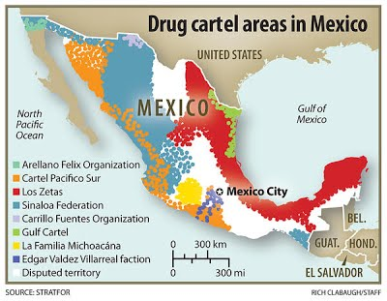
Step 1: Look Over the timeline of Mexico's Drug War
- Go to http://www.washingtonpost.com/wp-srv/world/special/mexico-drug-war-timeline/ in order to find the timeline. (will need to scroll down)
- Read through the timeline and answer the following questions in complete sentences.
- Why does the United States send a $1.6 billion Security Aid package to Mexico in October of 2007?
- Why do the drug cartels begin to target journalists in January 2009?
- In January 2011, over 150 inmates escape from a Mexican prison. Why are Mexico's issues with its prison system an issue in the continuing fight against the drug cartels? (Why is this prison break such a big deal?)
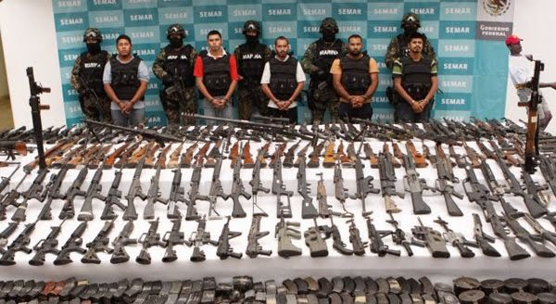

Step 2: New York Times Video & Questions:
- Pre-read the questions below, watch the video, and then answer the questions in complete sentences after watching.
- When living under threat of violence, is it better to withdraw from the community to make yourself less conspicuous or to band together as a community to support each other or fight back?
Clarifying ideas to help answer the question fully:
  - What could be benefits or drawbacks of each approach?
  - Which is your first instinct?
  - Is either approach risky or dangerous?
2. Security analyst Eduardo Guerrero is quoted as saying “the violence is very difficult to stop once it crosses a [certain level].” What does he mean by this?

http://www.nytimes.com/packages/html/world/2009-mexican-cartel/index.html

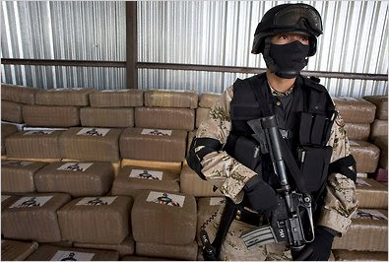

Step 3: Read the related article and answer the question given:
- http://www.nydailynews.com/news/world/mexico-releases-drug-war-death-toll-estimate-killing-hour-article-1.1005618?print
Chris Sabatini is quoted in the article as saying, "As long as it stays south of the [United States] border, I think most people won't care."
- Do you agree with Sabatini that people in the United States will ignore violence in Mexico as long as it is not happening here? Explain why you agree or disagree in 3-4 sentences.
