Technology Today WebQuest
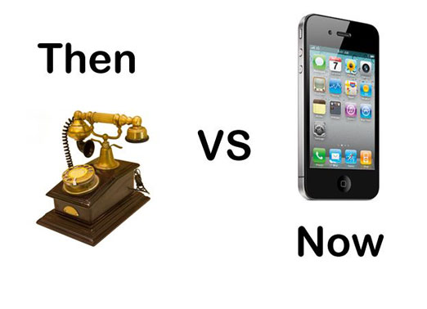
Introduction

Technology...What is it? Why do we need it? How do we use it? The most important question truly is...What would we do without it?

This WebQuest is set up to help you truly see how much we rely on technology and how little we would be able to do without it.

The Task

The goal of this WebQuest is to research and see how many changes there have been in technology over the years. You will need to list the technology, and then under its name you will need to state or show a picture of how that piece of technology changed and the time frame that the change occurred in.

Here are some things to consider when forming your list:
- Consider the resources that are listed within the WebQuest
- Be sure to include more than just the resources that are within the page.
- The more forms of technology listed the better
- The more changes you can list for a piece of technology, the better.
- Be creative and have fun
This material can be presented in any way that you choose. This can include:
- Word Processing Application
- Presentation Application
- Or any other format that you see as acceptable

The Process

Make sure to follow the steps that are listed and follow them in order to successfully complete this WebQuest.
- Begin by deciding what media you are going to use to compile the information you gather.
- Next design the layout of the project so that it is consistent and attractive to the eye.
- Begin by looking for resources on the web, including the ones that have been included within the WebQuest.
- Once you have complied what you believe to be a sufficient amount of resources, you may then begin your documentation.
- For each technology that has changed (Computer, phone, TV, etc...) make sure to list the technology and include a description of its main purpose.
- After this has been done, list the changes that technology has gone through, as well as the time period that each change happened.
  - Example: Phone cell phone 1992 (This may not be accurate information)
- Be creative and go beyond what guidelines are given here. These are just the things that have to be included.
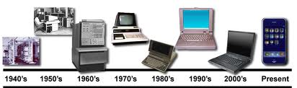

Resources
- http://www.centertech.org/
- http://www.foxnews.com/slideshow/tech/2011/10/17/technology-then-and-now/#slide=1
- http://www.cio.com/article/655946/Then_and_Now_How_Technology_Has_Changed_Our_Lives?page=1#slideshow
- http://www.time.com/time/specials/packages/completelist/0,29569,2033483,00.html
- http://www.telegraph.co.uk/technology/picture-galleries/9306467/Queens-Diamond-Jubilee-Technology-then-and-now-60-years-in-pictures.html

