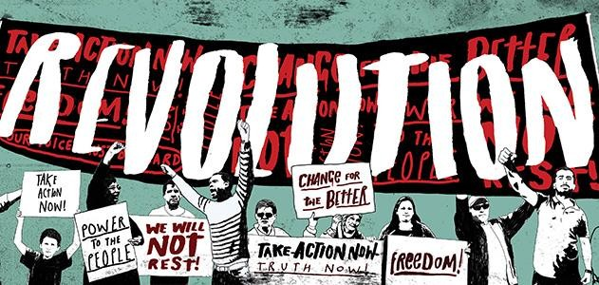

Time to join the Revolution!

Choose ONE of the following revolutions to research:

Russian Revolution (1917) | Cuban Revolution (1953) | Iranian Revolution (1979)
Tunisian Revolution (2010) | Libyan Revolution (2010) | Egyptian Revolution (2011)

- Answer the questions in bold about the revolution of your choice the options are listed below.
  - The italic questions are there to help guide you.
  - EXTRA CREDIT Include some pictures of important people and events to improve your presentation of the information!!!
- Remember to cite your sources.

- Name, date(s) and location of revolution:

- Who revolted? What did most of the people who came together to revolt have in common? Class, race/ethnicity, religion, political affiliation? Or was it the people as a whole?

- Why did they revolt? Who was the person/people in government that they were revolting against? Why were people unhappy with their government? Why did they believe that revolution was the only way to make the change that they wanted?

- How did they organize? Was the revolution planned for a long time? Was it spontaneous? How did people find out about the revolution? Were there leaders who did the organizing?

- How did the people overthrow the government? Did they take over government buildings? Did they assassinate leaders? Did they engage in peaceful demonstrations? Did they have the support of the military? Did they engage in acts of warfare?

- How did the government respond? Did leaders peacefully give in to the people's demands? If so, how long did it take for them to give in? Did they fight back using military force?

- How was the government the same or different following the revolution? What type of government emerged after the revolution? Why?

- In your opinion, was this revolution "successful"? (All political revolutions result in a changed or different government. Was the change better or worse for the people in this country? Explain your opinion using facts and evidence from your research to support it.)

- Include a map that shows the country in which this revolution happened

SOURCES: (provide the links)

