Name

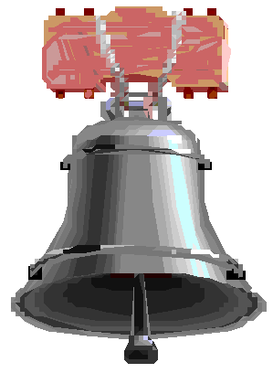Comparing and Contrasting
Patriots and Loyalists

Directions: Read the following debate between a Patriot and a Loyalist on the questions separating the 13 Colonies from England. Then complete the questions below.

LOYALIST: If we separate from England, it will be disastrous for business. England not only provides us with a market for our goods, but she protects our trade on land as well as at sea. As colonies of the British Empire, we have grown very prosperous; on our own we face certain ruin.

PATRIOT: We will be much better off without England controlling our trade. We’ll be free to trade with anyone we please and we won’t be forced to buy English manufac- tured goods any longer. It’s high time for us to develop
our own manufacturing. England has been taking advan- tage of us too long; the time has come for us to strike out on our own.

LOYALIST: But to sever ties with our mother country is unthinkable. We are all English people; we speak the same language, have the same traditions, the same rights, and owe allegiance to the same king. To separate from England would be cutting ourselves off from all we hold dear.
PATRIOT: England and America are a long distance apart. That in itself is proof that one was never meant to rule over the other. Since coming to this country, we have learned to manage our affairs on our own. We are Ameri- cans now––not English people.

LOYALIST: It is true that we have learned to take care of certain of our affairs by ourselves. But, we still need to be under England’s guidance, under her friendly protection. The mother country is responsible for our system of law and order, and if we break from her, we shall lose that. People will be killed and property destroyed. Who will rule us, if not England’s Parliament and King. Every person will be a law unto himself, and the only rule will be that of “King Mob.” And can there be a tyranny worse than that of un- controlled democracy?

PATRIOT: There can be, and its name is King and Parlia- ment! They are determined to deprive us of the rights to which we were born. They would tax us, but give us no
say in how we are governed. True freedom can only come when we have shaken off this yoke that weighs so heavily on us.

1. Why does the Loyalist believe separation from England would be “disastrous for business?”

2. What is the Patriot’s view on the effects on business if the Colonies separate?

3. Does the Loyalist feel more English or American?

Why?

4. Does the Patriot feel more English or American?

Why?

5. Look up in a dictionary and write down the definition of “tyranny”

6. To the Loyalist which is more dangerous––a king or democracy?

Why?

7. To the Patriot, who represents the worst tyranny?
Why?

