Zoot Suit Riots
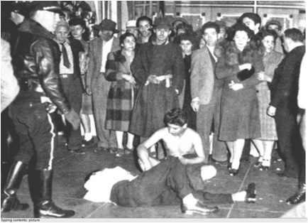
Crowd gathers around beaten and stripped Pachuco. (Associated Press)

Sources of Conflict
The Zoot Suit Riots were influenced by the 1942 Sleepy Lagoon Trial that fostered an atmosphere of hate and prejudice towards the Mexican American community. In 1943, conflict broke out on the streets of Los Angeles between servicemen and young Pachucos and Pachucas. During the riots which broke out on May 31, 1943 in Los Angeles, servicemen targeted Pachuco youth wearing zoot suits, who were all underage youth too young to be drafted by the service. Servicemen physically beat zoot-suiters, stripped them of their zoot suits, cut their duck tails and destroyed their clothing as the Los Angeles Police Department stood by and watched. The Zoot Suit Riots have been interpreted as a clash between uniformed gangs: the U.S. militaryissued uniformed servicemen, law enforcement and Mexican American youth donning a creative uniform of their own making. Several elements fed the flame that incited these riots:
- Newspapers were eager to distract attention from the war and single out what they falsely determined were internal enemies and thus, negatively publicized Pachuco gangs as scapegoats.
- Servicemen, who came from all corners of the United States, naively formed racist attitudes about zoot suiters based on stories published by the press.
- Growing public sentiment viewed Pachuco zoot suiters as “foreign,” un-American and a threat to war time patriotism.
- Law enforcement held very prejudiced views of Mexican Americans, Pachuco youth and Native Americans, as stated in the following quote:
…“they [Mexican authorities] have stated that which we are now learning the
hard way. The Mexican Indian is mostly Indian — and that is the element which
migrated to the United States in such large numbers and looks upon leniency by
authorities as an evidence of weakness or fear, or else he considers that he was able
to outsmart the authorities.” —Los Angeles Lieutenant Sheriff Edward D. Ayres

Riots of 1943: Sequence of Events
- May 31: Twelve sailors and servicemen clashed violently with Pachuco youth near downtown Los Angeles.
- June 3: Fifty sailors leave the Naval Reserve Armory in Chávez Ravine, near Chinatown, attacking anyone wearing zoot suits.
- June 4-5: Rioting servicemen conduct search-and-destroy raids on Mexican Americans in the downtown area.
- June 6: The rioting escalates and spreads into East Los Angeles.
- June 7: The worst of the rioting occurs.
- June 8: Major rioting ends in Los Angeles but spreads into other ports and urban centers such as Detroit, Chicago, Philadelphia and Harlem where African Americans dressed in zoot suits become targets.
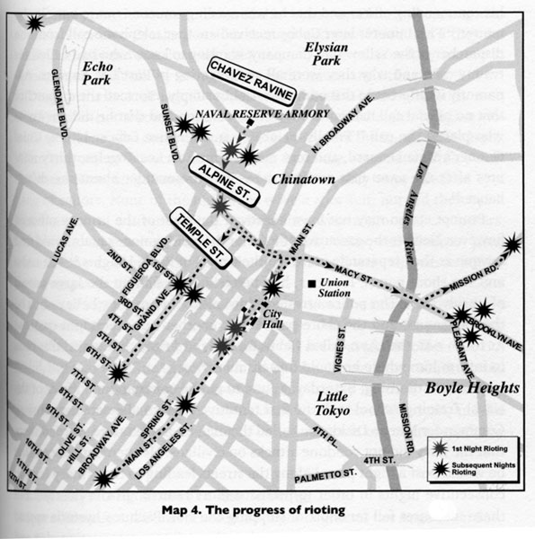
The progress of rioting, 1943. Murder At The Sleepy Lagoon Zoot Suits, Race, & Riot in Wartime L.A. by Eduardo Obregon Pagan (The University of North Carolina Press 2003)

Power of the Press
The press played a large role in shaping public opinion concerning the Sleepy Lagoon Murder Trial, the Zoot Suit Riots and subsequently of Mexican and Mexican Americans in the United States. This sensationalist misrepresentation of Pachuco youth and gangs was a form of yellow journalism.
Yellow journalism emerged in the early 1900s. It was sparked by the style of newspaper magnet Joseph Pulitzer and furthered by journalists working under William Randolph Hearst, who transformed publications into sensationalist propaganda sheets in order to increase sales. With incrementing sales, newspapers became so powerful that they began to greatly impact public opinion.
Newspaper articles written during the 1940s on Pachuco and Pachuca youth highlighted delinquency and non-conformity in behavior and language. One article in the Los Angeles Times in July 16, 1944 titled, “Youthful Gang Secrets Exposed,” sought to uncover the foreign underworld of Pachuco language. The article reported: “Gang members speak a strange argot unintelligible to the uninitiated.” Press reports like this fueled mass paranoia concerning the
American allegiance of Mexican youth in the United States during war time efforts.

Declaring an End to the Zoot Suit Riots
Realizing the disastrous international effects of the riots several measures were finally taken to end the Zoot Suit Riots. Federal Government officials in Washington, D.C. placed pressure on various government officials to stop the conflict. Among actions taken, the:
- Navy canceled all shore leaves and declared downtown Los Angeles out of bounds to all service men.
- Mexican Ambassador in Washington, D.C. requested Secretary of State Edward Stettinius to conduct a formal inquiry into the matter.
- Press was pressured to cease printing negative reports misrepresenting Mexican American zoot suit-wearing youth.

