The Greatest Movie Ever Sold (2011)

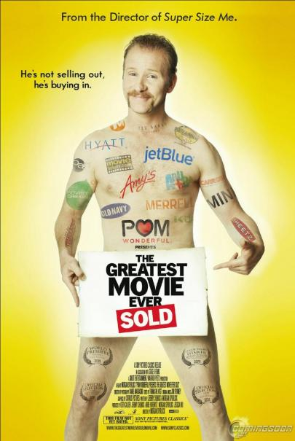
Synopsis:
Director Morgan Spurlock (Super Size Me, 30 Days) examines the increased proliferation of branding in every aspect of our lives while attempting to persuade big-name brands to sponsor his irreverent exposé. Companies love to push their products, and it seems like everywhere we go, someone is trying to sell us something. But have you ever wondered what goes on behind closed doors at some of the biggest advertising agencies in the world? In this eye-opening documentary, viewers follow Spurlock as he convinces a variety of high-profile sponsors to let him pitch their products as "The Greatest," while still maintaining complete control over his creative vision -- an arrangement that's become increasingly rare in the high-stakes entertainment industry.

Your assignment after watching the movie:
Answer the following questions in a well-written, clearly-developed persuasive paragraph please use examples from your own opinions and experiences.

- What is a brand personality?

- How are trailers created using neuromarketing?

- What does Susan Linn, author of Consuming Kids, suggest that advertising is doing to children?

- How do brands use music? Why is this an opportunity for musicians?

- How does it make you feel to know that companies have been targeting you through the movies and TV shows you watch? How have they been targeting you? What strategies have they been using?

- Should product placement be banned, or is it the cost of doing business? How can people become savvier (smarter / more aware) about the practice?

