Mock Trial
U.S. v. Michael Davis
A college student is charged with felony rape after his girlfriend alleges that he forced her to have sexual intercourse against her will. (This is an updated version of U.S. v. David Jones)

Developed by the D.C. Street Law Clinic at Georgetown University Law Center

Distributed by Street Law, Inc.

This trial may be used and duplicated for non-commercial academic use.

IN THE SUPERIOR COURT
OF THE DISTRICT OF NEW COLUMBIA

---------------------------------------------------------x
:
United States :
:
:
-v- : Civil Case No.: CV01-192009
:
:
Michael Davis :
:
---------------------------------------------------------x

STIPULATED FACTS1

Ashley Williams is a 21-year-old senior majoring in business at New Columbia University. Ashley lives with a roommate, Pat Daniels, at 110 Michigan Ave, N.E., apartment 410, in Metropolitan, New Columbia. Pat Daniels, also a student at New Columbia University, majors in communications. Michael Davis is a 22 year old senior also majoring in business.
Michael lives with a roommate, Terry Washington, at 3601 Connecticut Ave, N.W., apartment 2B, in New Columbia.
Ashley has been taking birth control pills since she was 16 years old. Her doctor prescribed this as a treatment to correct her medical problem of irregular menstrual cycles.
Ashley and Michael met and began dating in October 2005 during their freshman year (2005-06). They dated until May 2006. During this first relationship, Ashley and Michael had

1 The foregoing summary of the case is provided solely for the convenience of the participants in the Mock Trial Tournament. This overview itself does not constitute evidence and may not be introduced at trial or used as impeachment. All parties agree and stipulate to the accuracy of the stipulated facts.

sexual intercourse. After a 15-month separation, Ashley and Michael began dating again in September 2007. This second relationship lasted from September 2007 until December 7, 2007.
On Thursday, December 6, 2007, Ashley and Michael attended an off-campus party.

Afterward, Ashley returned with Michael to his apartment. Sexual intercourse took place early on the morning of December, 7, 2007. No one else was present in the apartment that night.
Ashley made her first formal allegation that Michael raped her to Randy Miller, a counselor at the New Columbia University Health Clinic. She made this allegation on December 8, 2007. She filed a formal complaint with the Metropolitan Police Department on Monday, December 10, 2007.
On December 11, 2007, Detective Jessie Young obtained a legal warrant to search Michael’s Connecticut Avenue apartment. As a result of the search, the police found a torn shirt matching the description of the shirt Ashley said she was wearing at the time of the alleged rape. Michael Davis was later arrested and charged with raping Ashley Williams.

CHARGES AND DEFENSE

The State of New Columbia charges that Michael Davis forcibly overpowered Ashley Williams on the morning of December 7, 2007, forcing her to have sexual intercourse against her will. This act amounts to first degree sexual abuse or one of the lesser included offenses of second degree sexual abuse or misdemeanor sexual abuse, pursuant to New Columbia Code section 22-3002, 22-3004, and 22-3006. The State of New Columbia urges the judge to find Michael Davis guilty of this offense and sentence him accordingly to a term of years in prison.
Michael Davis, defendant, claims that Ashley Williams was a voluntary participant in all activities that occurred on the morning of December 7, 2007. Therefore, Michael Davis requests

that the court find him not guilty, based on the defense that he acted with Ashley Williams’ full consent.

WITNESSES TO BE CALLED AT TRIAL

Prosecution

Ashley Williams, alleged sexual assault survivor.

Randy Miller, rape counselor, New Columbia University Health Clinic. Jessie Young, Detective, Sex Crimes Unit, Metropolitan Police Department.

Defense

Michael Davis, Defendant.

Terry Washington, roommate of Michael Davis. Lee Stream, Psychologist.

EVIDENCE

Police Report by Detective Jessie Young.

Pages taken from the personal journal of Ashley Williams. Photographs of defendant’s apartment.
*All witness affidavits are sworn statements.

[This Page Intentionally Left Blank]

APPLICABLE LAW

Statutory Law:

New Columbia Code section 22-3002. First degree sexual abuse.

A person shall be imprisoned for any term of years or for life, and in addition, may be fined in an amount not to exceed $ 250,000, if that person engages in or causes another person to engage in or submit to a sexual act in the following manner:
(1) By using force against that other person;

New Columbia Code section 22-3004. Third degree sexual abuse.

A person shall be imprisoned for not more than 10 years and may be fined in an amount not to

exceed $100,000, if that person engages in or causes sexual contact with or by another person in the following manner:
(1) By using force against that other person;

New Columbia Code section 22-3006. Misdemeanor sexual abuse.

Whoever engages in a sexual act or sexual contact with another person and who should have knowledge or reason to know that the act was committed without that other person's permission, shall be imprisoned for not more than 180 days and, in addition, may be fined in an amount not to exceed $1,000.

New Columbia Code section 22-3007. Defense to sexual abuse.

Consent by the victim is a defense, which the defendant must establish by a preponderance of the evidence, to a prosecution under sections 22-3002 to 22-3006.

Case Law:

Masters v. United States, 810 A.2d. 966 (2006).*

Summary of Facts: On appeal. John Masters was convicted of raping the complaining witness on the night of October 12, 2005, in the back seat of Masters’ car in a parking lot of a local shopping center. Masters met the complaining witness for the first time earlier that evening at a gathering at a friend’s (Jason White) house. The complaining witness was in need of a ride home, and Masters volunteered to drop her off. Relying on the knowledge that Masters was a trusted friend of White’s, the complaining witness accepted the offer.
On the way home, Masters pulled over into an empty parking lot and overpowered the complaining witness, forcing her to have sexual intercourse with him. Masters is a large man, 6’3” tall, weighing 205 pounds, and muscularly built; whereas the complaining witness is substantially smaller in size and stature, 5’4” tall and 132 pounds. Masters allegedly slapped the complaining witness across the face, resulting in multiple bruises that were shown in the pictures admitted as part of the District’s evidence. Meanwhile, he continually threatened the complaining witness with severe bodily harm if she did not comply with his demands to “give me what I want right now.” The complaining witness testified that she stopped putting up any sort of resistance for fear of further, more severe harm.
As soon as she was able, the complaining witness freed herself from Masters’ control, fled from the car, and immediately sought assistance. The police were summoned right away, and within five minutes of the call, they found Masters, just as he was described by the complaining witness, passed out in the back seat of the car with his pants and undergarments down. Masters was tried and convicted of felony rape.

Holding: In any prosecution for rape, there must be the absence of consent by the complaining witness to warrant conviction. Masters contends that since the complaining witness admitted that she gave up her defensive efforts against him, she effectively consented to further acts. This court finds, however, that the cessation of resistance by the complaining witness was an act of submission to an overwhelming force. Submission cannot be considered “consent” because it was induced by putting the woman in fear of grave bodily harm or death, or by exercise of actual force against her person. Utmost resistance by the complaining witness is not required. Furthermore, specific intent to commit a rape is not required to warrant a conviction, as long as it can be proved that a rape occurred.
In this case, ample evidence existed to warrant a conviction of felony rape by the lower court. Based on (1) the testimony of the complaining witness, (2) the witnesses from the parking area who encountered the complaining witness as she fled from the car, (3) the police officers who found Masters shortly after receiving report of the attack, and (4) the medical examination evidence and pictures of the bruises. Judgment of the trial court is Affirmed.

Campbell v. United States, 805 A.2d. 196 (2003).*

Summary of Facts: On appeal. On the afternoon of March 21, 2002, Jane Smith was allegedly attacked and sexually assaulted by the defendant, Thomas Campbell, in Smith’s own home. Campbell and Smith were acquaintances via mutual friends. They saw each other intermittently at various social functions and parties, and they knew each other for about five years prior to the attack. Campbell owned a painting company, and when Smith decided to repaint her house, she contacted him for an estimate. He came over with his assistant and completed the estimate, after which, he and his assistant both left. Campbell, however, returned

an hour later, claiming that he had left some papers behind. Meanwhile, Smith had decided to take a bath. When the doorbell rang, she answered the door wearing only her bathrobe.
According to Smith’s testimony, Campbell entered the house, claiming to be looking for misplaced documents. Then, while she was helping him look for the papers, he grabbed her from behind and forced himself on her. Smith claimed that she never acted in any manner to provoke the attack.
Campbell’s testimony claimed that when he returned to the house and saw that he had interrupted Smith’s bath, he offered to come back at a time more convenient to Smith, but that she insisted he come in. Campbell further claimed that Smith then “moved around the house in a very provocative manner,” allowing her bathrobe to fall open, bearing her shoulders and legs to him. Campbell does not deny having sexual intercourse with Smith. He claims, however, that it was with her full consent and invitation.
After the incident, Smith apparently left her home and went to her sister’s apartment, where she spent the next few days. She did not call the police to report the incident for a week following the alleged attack, and she did not have a medical examination.
Police investigation of the Smith home did not reveal evidence that any struggle occurred, although the bed sheets appeared to be pulled partially off the bed. No one else was present in the home or witnessed Campbell’s coming or going.
At trial, Campbell was convicted of rape based solely upon the testimony of the complaining witness, Smith.
Holding: The case presented against Campbell is highly circumstantial. The complaining witness is the only one to provide direct testimony regarding the allegations. Smith delayed reporting the attack for seven days and did not have a medical examination. Furthermore, police

search of the premises revealed no evidence of struggle. This court has held previously that rape charges must be corroborated, and that circumstantial evidence may be sufficient to corroborate rape charges as long as there is enough evidence in total to show guilt beyond a reasonable doubt. In this case, however, there is no corroborating evidence. Is it clear from reviewing the record of the trial court that jurors acted with their hearts, and not their heads. Although one of the qualities of our justice system is the judge’s and jury’s ability to consider human factors such as sympathy in the decision-making process, these human factors cannot be a basis for a decision. Judgment of the trial court is Reversed.

*These cases are fictitious. For the purpose of this mock trial, however, they are interpretations of the application of the New Columbia Code section 22-3002 thru 22-3007 and are to be treated as binding precedent.

[This Page Intentionally Left Blank]

Affidavit of Ashley Williams

My name is Ashley Williams. I am a 21-year-old senior at New Columbia University, and I am majoring in business. I currently live at 110 Michigan Ave, N.E., apartment 410, in Metropolitan, New Columbia. I have been at this address since the beginning of my sophomore year. I live with my roommate Pat Daniels.
I met Michael Davis during my freshman year. We were both business majors, so we took three or four of the same classes. He borrowed notes from me a few times, and we talked a little now and then. In the middle of October, we started dating.
I really liked Michael a lot from the very start. We saw each other almost every day from mid-October to May. It was a pretty serious relationship at the time. We were very close emotionally, and we were sexually active as well. I was very much in love with him.
We were separated from each other the summer between our freshman and sophomore years. He got a job in Chicago for the summer and wanted me to come with him. I was going to go at first, but then I was offered a great job here for the summer and decided to stay instead. He didn’t like that very much, and we argued about it a lot. He couldn’t understand that although I wanted to be with him, I couldn’t pass up this opportunity. He probably thought I would go out with other guys if he was not around. That’s funny, since I heard he was dating other girls while he was in Chicago. It really hurt me that he could date someone so soon after we were apart.
At first, I called him a lot, but he never seemed very happy to hear from me, and he didn’t even call me once – he said he couldn’t afford it. When I did call him, he talked about the people he was meeting and the parties he would go to. He’d also try to make me feel guilty about not coming. He complained about how much money he could’ve saved if I had worked in Chicago and lived with him for the summer.

During the summer I realized that I had become very dependent upon him and that, if it continued, it would be very bad for me. I still loved him and missed being with him, but I could not allow the relationship to continue that way. We managed to avoid each other all of sophomore year. During the fall of my junior year, we ended up having a class together. I thought that I was over him, but once we had lunch together, we started talking again and some old feelings came back. One thing led to another, and we decided to give it one more try. I purposely kept some distance between us, emotionally and physically, because I wanted to make sure I didn’t become too dependent on him again. Although I fell in love with him again, I would
not have sex with him. I stayed over his apartment a lot during this second relationship. Although we stayed in his bedroom, we only had sex once, on my birthday, November 3rd. There were a few more times when we almost did, but I always made him stop. He would always persist a little, but in the end, he would back off. Sometimes it got really hard to say no, but I wasn’t ready yet, and he seemed to respect my decisions. That is, until the last time.
I know it probably appeared to his roommate, Terry, that we were very active sexually because I was over there a lot. Michael didn’t help the situation any when he would joke and hint about it in the morning – he’d make those remarks that guys think are funny – but we really usually stayed up talking or watching late movies.
I don’t know exactly how it all happened. On December 6, 2007, we went to a party. I had a couple of beers there, and I know that Michael had a few as well. I didn’t think that either of us was drunk, though, maybe just a little buzzed. I know I wasn’t drunk because if I were, I probably wouldn’t have tried to stop him later. We had a great time at the party, although Michael spent a lot of time with Jenny Jackson. I wasn’t too happy about that.

We left the party and went back to his apartment. After we went to his room, he went to the bathroom, and I laid down on his bed to rest. When he came back, we started kissing, and he started to unbutton my shirt. I pushed his hand away, but a little while later, he tried again. I was enjoying the kissing and touching for a few minutes, but then I began to get nervous and said, “Please stop!” He said I wasn’t being fair to him, and if I really loved him, I would show him. I told him, “No. I don’t want to.” I did love him, and it was so hard for me to say no because I wanted to make him happy, but I just wasn’t ready. I thought he understood that. He said I was playing games with him because we had done it before. I don’t see why that should matter.
I didn’t want to yell at him; I didn’t want to start a fight. I was very serious when I told him no, but he wouldn’t listen. I tried to get out of bed, but he grabbed my shirt and my arm and pulled me back, ripping my shirt and twisting my arm. He pulled my skirt up, pulled down my underpants and forced me to have sex with him.
Afterwards, I was upset. I put on my underpants and took off my ripped shirt. I couldn’t stand to have it on me anymore. Then I put on an old sweatshirt and sat down in the chair at his desk. I wanted to talk to him, tell him I was angry and that he shouldn’t have forced me, but I was afraid I would start crying so I didn’t say anything. I just sat there staring at the desk and trying not to cry. I saw some stupid note this girl Jenny had written to Michael. The note said, “Honey, you’re a great husband. See you tomorrow.” The note bothered me, but it wasn’t the reason why I was upset. He asked me what I was doing at the desk. I didn’t answer because I knew if I opened my mouth, I would either cry or yell at him. I just walked out and slammed the door.
I went back to my apartment. Pat, my roommate, could tell I was upset and asked me what was wrong, but I couldn’t talk about it. I really wanted to, but I couldn’t get the words to

come out. I took a shower, locked my door, and cried myself to sleep. Later that day, December 7, I told Pat I wasn’t feeling well, and I skipped my classes. I felt like I was frozen, like all I could do was cry. All I could manage to do that whole day was write in my journal. I’ve written in my journal since high school, but since college I only write in it when something really meaningful happens. When Pat got back from classes, I was finally able to talk about what had happened. Pat suggested I go to the doctor or at least talk to someone at the school clinic.
At first I didn’t want to go to the clinic. Michael was my boyfriend, we were at his apartment, and we had been drinking. I didn’t think anyone would believe me, and what could I do about it anyway? Also, I didn’t want my family and friends to hear about it. A part of me was wondering if I could have done something more to prevent it, if maybe it was my fault in some way. I felt hurt, confused, angry, doubtful, and scared all at once. I didn’t know what to do. Pat and I talked for a long time and finally agreed to go to talk to a counselor.
The next day, December 8th, I met with Randy Miller, who is a rape counselor at the

clinic. Randy told me a lot of information about date rapes on college campuses, and that my psychological reactions and especially self-doubt were normal, but that I shouldn’t blame myself. A part of me didn’t think that a person could be raped by her boyfriend. Randy said that no means no, and if it was against my will it was rape.
The next few days were hard because I felt like somehow everyone knew, even though I know now that they didn’t. I felt ashamed and humiliated. Talking with Pat and Randy really helped. They kept suggesting that I report it to the police. Eventually, on December 10, I got enough nerve to go.
It’s still hard to deal with. I am still angry at Michael. I do everything I can just to avoid him. I still have nightmares sometimes, and I lost a lot of weight for a while afterwards. I wonder

if he knows any of this, or if he even realizes what he did was wrong. I really know now that it wasn’t my fault. I took me a while to realize it, but I’m sure of it. I really loved and trusted him, but he abused that love and he broke that trust. Someone has to make Michael realize what he did was wrong.

[This Page Intentionally Left Blank]

Affidavit of Randy Miller

My name is Randy Miller. I work at the New Columbia University Health Clinic as a psychological counselor. I have a bachelor’s degree in psychology and a master’s degree in social work. I have worked here for five years – during the first two years, I was a general counselor, but I’ve specialized in assisting rape and sexual assault victims for the last three years. Previously, I volunteered as a hotline counselor for the clinic two or three times a week during my sophomore, junior, and senior years at New Columbia University. I became interested in the clinics' rape assistance program because my sister was raped while she was in college, and I witnessed the trauma she went through at the time.
I met Ashley Williams for the first time on the morning of December 8th. When she

entered my office, she appeared very calm, and she seemed to answer my preliminary questions without any problems. When I began to question her about Michael and her relationship with him, however, she became tense and uneasy. I could tell that it was difficult for her to talk about him without getting very angry and upset. She was fighting back the tears.
As she told me about what happened, she displayed a wide variety of emotional reactions She was angry one minute, then smiling and laughing the next, then she’d become withdrawn and sad. She even cried a couple of times. She expressed her worries that maybe in some way she was to blame for what had happened to her. She was afraid that she may have led Michael on somehow, that she may have asked for it. Ashley seemed very open and honest.
She showed me her personal journal. The entry she wrote the day after the attack indicated her emotional confusion, anger and pain. She did not recount in detail what had happened, however, and she did not use the word rape specifically, because at the time she did not realize that was what actually happened to her.

Ashley’s reaction was pretty normal, if there is such a thing where sexual assault survivors – we prefer to call them survivors rather than victims – are concerned. In truth, there is no set reaction that can be expected from someone who was raped, but psychologists and medical professionals have recognized some fairly common patterns of reactions that they have termed the “Rape Trauma Syndrome” (RTS). RTS consists of two phases. The first, the acute phase, which is the period immediately following the attack, is characterized by extreme disorganization and disturbance. During this time, a woman may become excessively emotional, or alternatively, she may try to completely mask her emotions. Physically, she may experience tension and disturbances to her eating and sleeping routines. Emotionally, the survivor of a sexual assault may experience fear, denial, guilt or angry. Depending upon the woman, her reaction during the acute phase may include any combination of these aspects.
The other phase of RTS is the chronic phase that occurs approximately two to six weeks following the attack, although the duration may vary. Some women have little difficulty recovering completely and quickly, while others never fully recover. During the chronic phase, the survivor tries to reorganize her lifestyle. Some women have moved or changed jobs in reaction to sexual assault. Some women reach out to family and friends, some shy away more from fear of embarrassment. Social and work relationships often change, becoming more distant. Except for the survivor’s very closest friends, there is little trust for anyone else. The survivor may experience nightmares, and often develops fears and phobias, usually related to the circumstance of the rape itself.
A woman who has been raped often does not know how to react anymore. Being raped destroys a woman’s sense of self control, and that feeling of loss often spills over into other areas of her life including work, school and relationships with other men or with people in general.

Often, in response to his feeling of loss of control, a woman will do things to try to regain control of her life, and she’ll act in ways where she alone has control over what happens.
For instance, when a woman delays reporting a rape, she often does so because that information is completely within her control before she tells anyone, but once she does tell, it is out of her hands. In counseling rape survivors, I try to emphasize the importance of coming forward and getting the police involved. Silence is permission – if a woman does not report a rapist, even if it’s someone they know very well, that person is free to rape again and again, and he probably will because he won’t realize what he has done was wrong.
In helping Ashley recover, there were a few key points I wanted make sure she realized. The first was that rape is a crime of violence, not of sex. Men who rape don’t do it for the sex itself. There are other, easier ways to do that. Rather, they do it for the sense of control or empowerment that they get in being able to force someone to succumb to the wishes. A woman cannot be held responsible for the arousal level a man experiences – it’s his body. Ashley did not force Michael to rape her; he made that decision and carried through with the actions himself. In the situation of date rape, misunderstanding and miscommunication between the man and woman can also be a contributing factor to the act. Although it may help explain why it happened, it does not negate the fact that a rape did occur, nor does it excuse the rapist from culpability.
Also, I wanted to make sure that Ashley knew that there is no right or wrong reaction to what happened to her. Any and all feelings that she had were real and valid, and that she shouldn’t be afraid to express them.

Another thing Ashley needed to be told was that alcohol cannot be used to excuse the act, even in a situation like this where both Ashley and Michael had been drinking. Alcohol does not reduce accountability in any other life situations. Take drunk driving as an example.
Finally, Ashley needed to know that she is definitely not alone. In the general population, a rape occurs every five to six minutes. In fact, one in every three women will experience a sexual assault or an attempted sexual assault in her lifetime. Women between the ages of 14 and 24 are at the highest risk. Surveys show that one in every four college women is raped. And what people find most surprising is that in 60-70 percent of all rapes the assailant is someone the victim knows. I don’t know of any statistics that show how often women falsely report rape, if they do so at all.
One major contributor to the ongoing problem is that often, men like Michael do not realize that what they have done is wrong. Our social system often works to encourage this kind of thinking in men. Somehow, people need to be educated. The men need to be more aware of their accountability, and the women need to be more sure of their bodily integrity.
From everything I’ve heard from Ashley about the case, Michael is guilty of rape. Men must be stopped from abusing women in this way.

Affidavit of Jessie Young

My name is Jessie Young. I am a 12-year veteran of the Metropolitan Police Department.

I am currently employed as a detective in the Sex Crimes Unit. I have been in this position for the last six years. As a member of this unit, I am responsible for answering and investigating claims of crimes of a sexual nature, such as: rape, sexual assault, prostitution, pornography, child molestation, and exploitation.
I am the detective in charge of investigating the alleged rape of Ashley Williams by Michael Davis. According to our records, the report of the alleged rape was first made on the afternoon of Monday, December 10, 2007, by Ms. Williams. Per procedure, I conducted an interview with Ms. Williams and recorded her statement.
I asked her questions which were standard in cases such as this, including whether she had a medical examination or any record of medically-confirmed evidence that a rape had occurred. She stated that she showered shortly after the incident, effectively eliminating such evidence, and since she had no other physical injuries other than a bruised arm, she did not see the need to go to the doctor. This is not unusual for rape victims. Unfortunately, right after the occurrence they are usually too upset or embarrassed to see a doctor. They also feel disgraced and dirty and just want to wash away any contact they had with the assailant. I wish these women would start to realize they would make our job a lot easier if they had an exam right after the incident instead of showering and waiting to see a doctor. However, upon close inspection, I could see that there were traces of what could have been bruises on her arm at the time of the interview. When I tried to photograph them, however, they were too faint to be seen in the pictures.

I also inquired as to the existence of any witnesses. She stated that she and Michael were the only people in the apartment at the time of the incident, and that she did not tell anyone what had happened until the next afternoon. At that time, she told her roommate, Pat Daniels, what had happened. She stated that Mr. Davis ripped the shirt she was wearing that night. When I asked her to bring the shirt, she stated that it was still at Mr. Davis’ apartment.
I got a search warrant for the Connecticut Avenue apartment and went there on December 11, 2007. Upon a search of that apartment, I found several articles of Ms. Williams’ clothing, including a shirt fitting the description of the one she was wearing that night. The shirt was torn along the side hem as if it has been pulled on with some degree of force. I read Mr. Davis his Miranda rights, which he waived. When I questioned him about how the shirt was torn, he seemed very defensive and said that if he had raped her, he was smart enough not to keep the shirt if it could later be used against him.
When I asked Mr. Davis what happened, he replied that that had made love that night and that she consented. He stated that Ms. Williams became angry after reading a note written to Mr. Davis by a classmate, Jenny Jackson. Mr. Davis explained that the nature of the note was jokingly romantic, as Ms. Jackson was merely playing along with the theme of their joint class project. I asked Mr. Davis to show me the note, but when he looked for it, he couldn’t find it. In an effort to corroborate his story, however, he did show me an assignment sheet which described the project he was working on and named Jenny Jackson as his “partner/spouse”.
There was no physical evidence of a struggle in Mr. Davis’ apartment or any evidence that Ms. Williams was there against her will. All the evidence relating to Ms. Williams in the apartment seemed to indicate her voluntary presence in the apartment, except for the torn shirt.

For example, several other articles of clothing were there, as well as a toothbrush, hairbrush, and some of her school books.
I also interviewed Pat Daniels, Randy Miller, and Terry Washington. None of them could claim any actual knowledge of the incident, although all three had heard about it from either Ms. Williams or Mr. Davis.
Basically, it all comes down to Ms. Williams’ word against Mr. Davis’. This is a typical for an alleged rape of this type. There aren’t any witnesses and no concrete evidence. A jury really needs to listen to both stories and decide who is telling the truth. I just gather the facts and evidence. I don’t make any judgments as to who is right or wrong.
But I can say that in my years of experience, I have seen several situations like this – maybe half a dozen – where there is little or no hard physical evidence, where there is a delay in reporting the crime, and where there are no witnesses. In some of those cases, the charges are brought out of spite, anger or jealously. However, in many cases the woman has been forced to have sexual intercourse without her consent. Even if the two individuals are adults and know each other well, one party should not be forced to have sex with another person without their consent.
I don’t know what type of situation this case is. Like I said, that’s not for me to say. Ms.

Williams says she was raped, and there are some facts to support this. On the other hand, Mr. Davis believes very strongly he did not do anything wrong either, and in my mind his explanation for the shirt and everything can be believable too.

[This Page Intentionally Left Blank]

Affidavit of Michael Davis

My name is Michael Davis. I’m 22 years old. My address is 3601 Connecticut Ave., N.W., apartment 2B, Metropolitan, New Columbia. I’m a senior at New Columbia University. I’m a business major with a minor in economics.
I first met Ashley Williams during freshman year. She seemed really nice and she was very helpful. We had several of the same classes, and she seemed pretty bright, so I asked to borrow notes from her. I missed classes occasionally because of work. Since my freshman year, I have worked part time at a local youth center. I help the director of the athletics department there develop and run programs to get kids off the streets and keep them out of trouble. Eventually, we started going out. I thought she was great, and I really enjoyed being with her.
I thought everything was going pretty well. Of course we had our share of arguments like every couple does, and there were times when I wanted to spend more time with my friends, but I ended up spending most of my time with her. I even had plans to spend the summer with her in Chicago where I was going to be working. I found us a place to stay and everything. I thought it was all set, then one day she said she was staying here because she got a job offer. Then she started worrying about the future, and what was going to happen between us and things like that. I couldn’t understand why she had to create problems when there weren’t any. I more or less just was taking things for what there were at the time, and I thought things between us were very good.
That summer we spent apart was pretty lonely for me. I was in a different state where I didn’t know anyone. I asked Ashley to come visit me, but she said she couldn’t afford it. She called a few times in the beginning of the summer, but then I got fewer and fewer calls until they

just stopped. I couldn’t really afford to come back here or call her very often since I was paying for both my Metropolitan apartment and the place I was staying at in Chicago. When I tried to explain that to her, she said she was just as busy as I was and just as tight financially, and if I really wanted to be with her, I would figure out a way to do it. I didn’t know what she expected me to do, so I did what I could to keep myself busy. I went out with some friends I met at the office and at some parties, but just for fun. I didn’t date anyone, I just hung out. She had her friends here, and I had no one. What else was I supposed to do?
That next year things weren’t the same, so we didn’t see each other. But then last year we had a class together, and somehow things started up again. Ashley kept saying she didn’t want to make the same mistakes. I wasn’t exactly sure what mistakes she was talking about, but she seemed very happy, so I didn’t worry about it. I was just a little more careful not to push her too much – I kept my distance a little more, but eventually she began to stay over again, and things seemed like they were getting to be the way they used to be.
Since we’ve been back together, we had sex once before December 6th – on her birthday.

But most of the time she stayed over, we’d just watch TV or hang out. We would stay together in my bedroom. I take sex seriously, unlike some guys I know. I always told Ashley that, too, so when she didn’t want to do it, I didn’t force the issue. When Ashley would say no I knew she meant it, like one night about a week before when she got mad and walked out at 2:00 in the morning. Besides, Ashley and I were very smart about sex. She was taking birth control pills, so I knew she wouldn’t get pregnant.
Then one night we went to a party at one of my buddies’ apartments. We had a great time, and I felt like things were better than ever. I remember at one point she seemed a little mad at me – like she was jealous or something – because I was talking to this girl, Jenny Jackson, for

a while. When I explained that Jenny and I were working on an economic project together, everything seemed all right.
Later, I asked Ashley to come back to my place with me, and she said okay. She got into bed, and I went to the bathroom to put on a condom, just in case we had sex. I got into bed with Ashley, and we started kissing. She said no or stop once or twice, but she didn’t act like she meant it. I thought she was just playing because she would smile and laugh and start kissing me again. Even when she got out of the bed, and I pulled her back by her shirt and accidentally tore it. She was a little mad about the shirt, but then we kissed again and she didn’t say anything about it. I asked her to take off her clothes but she said no so we didn’t bother with it. We made love. It was very special to me, like the night of her birthday. I thought she felt the same way too. I had a few beers at the party and may have been a little buzzed when we left the party, but by the time we had sex, I was fine. I knew what was happening and so did she.
Afterwards, she got up and went over to my desk. Ashley found this note Jenny wrote to me about meeting to discuss our economics project, but she misinterpreted it. My project involved doing budgets as if we were husband and wife. Jenny is a really fun girl who likes to goof around a lot. The note said, “Honey, you’re a great husband. See you tomorrow.” It was completely harmless.. Ashley was upset but didn’t say anything. She just stormed out and slammed the door.
I figured I should just give her a little time to cool off. The next morning, I went to class thinking I would see her, but she wasn’t there. I ran into Pat, her roommate, and asked where she was. Pat said Ashley wasn’t feeling well. I wanted to go by and check on her, but I had to ref a basketball game at the center. It was the championships, and I couldn’t miss it. I got home pretty late that night and I tried to call, but I got the answering machine. I kept leaving messages that

night and the next day, but she never called me back. It was pretty clear that Ashley was still mad. I couldn’t believe she got so jealous.
I even had my roommate Terry try to talk to her to find out what was going on, but Ashley wouldn’t talk to Terry either. I thought that was really strange because she and Terry have been pretty good friends. I didn’t know when or if she was ever going to cool down enough to let me explain things.
I even went to see her but Pat wouldn’t let me in. Finally, I figured the only thing I could do was give her some space and time to cool off, if that was what she needed. I figured when she was ready, she would talk to me again. We’ve always been able to talk about things. I thought I was doing what she wanted me to. I had no idea all this stuff was going on until Detective Young came by a couple days later. I was in shock.
Detective Young had a warrant to look for Ashley’s shirt, and asked to have a look around. Detective Young found the shirt and took it, along with a few other things that belonged to Ashley. The officer also asked me a few questions, which I answered.
I’ve been with Ashley for a long time. I thought I knew how she felt about me, but apparently I didn’t. But I know for sure that on that night she felt the same way I did. I could tell. She didn’t get mad until afterwards. I certainly didn’t force her to do anything that she didn’t want to, and I didn’t hurt her. I loved her, I would never do that to her. I thought she loved me as much as I loved her. I guess I was wrong, about her feelings, I mean. She’s definitely not the person I thought she was – I never thought she could lie like this.

Affidavit of Lee Streams

My name is Lee Streams and I’m a practicing psychologist. I have my own private practice. I have a B.A. in psychology and a master’s degree and a doctorate in clinical psychology. I’ve been in practice for 10 years and see different types of patients, but my focus has been on adolescent psychology.
Michael Davis first came to see me a couple of days after his arrest. He was naturally quite upset and couldn’t understand why Ashley was claiming Michael raped her. He discussed his relationship with Ashley and it clearly sounded as if they cared a great deal for each other. They had gotten back together after they had broken up the year before. Things seemed to be going well, even if Ashley did get a little jealous at times.
Michael came to see me for five one-hour sessions. During these sessions we discussed his relationship with Ashley and other women, his attitude towards sex, and how he reacts to unfavorable situations. In addition, I administered a battery of psychological tests.
From the results of the tests and our talks, I have come to the conclusion that Michael Davis is a stable young man with a positive attitude towards sex. There has been nothing in our talks or in the tests to indicate Michael is a violent person. Rape is a violent crime and Michael does not react in that way. He has very rarely been in any fights and tends to avoid confrontations. In my opinion, Michael is an honest person.
Michael enjoys sex and is quite open about that. Although he has only been seeing Ashley at this time, he has never had any problems asking women out. He is a nice-looking young man and has no shortage of dates. There is no reason for Michael to force himself on someone. All of us have been in situations where we get carried away by the emotions of the

moment and we might be sorry we did something when we look back. Ashley may have felt she should not have slept with Michael when she looked back at the night, but that doesn’t mean Michael forced himself on her.
A lot of women seem to want everything their way. They want to be able to have sex when they want to and will often lead a man on. If things go too far, then they start crying rape when they know they wanted it all along. Ashley and Michael spent a lot of time alone together. They were in Michael’s room and in his bed. They had sexual intercourse previously. I’m sure Ashley knew Michael would want to have sex. What healthy man wouldn’t? If Ashley didn’t want to have sex with Michael she just shouldn’t have been there with him. Women have to take some responsibility for their actions.
The basic issue in these cases is whether the woman gave her consent, or whether she was forced or coerced. The problem is that some experts think that unless a woman actually says “yes” before she has sex, it is rape. In my opinion, a woman can give consent in other ways besides saying “yes”. For example, she can encourage the man with body language, facial expressions, or continued kissing.
Ashley having symptoms like the Rape Trauma Syndrome doesn’t mean anything. The so-called reactions in RTS are so vague that she could have been reacting to anything or it could have been a normal pattern of behavior. She could’ve felt bad about the way she was treating Michael and didn’t know what to do.
Michael is very confused at this point. He has been in a relationship with Ashley for quite some time and thought they had something very serious together. He still can’t understand why she reacted this way. It seems a little ridiculous to cause all these problems just because she was jealous over a silly note from another girl.

Since I am an expert in my field, Michael has paid me my usual $100-per-hour fee for his visits. For testifying Michael has paid me an additional $400. I don’t think Michael should be treated this way by Ashley. He needs some protection too.

[This Page Intentionally Left Blank]

Affidavit of Terry Washington

My name is Terry Washington. I live at 3601 Connecticut Ave., N.W., apartment 2B, Metropolitan, New Columbia. I’m 21 years old, and a senior at New Columbia University, majoring in political science.
I’ve known Michael Davis for almost seven years. We went to the same high school together. He and I have always been really good friends. For as long as I’ve known him, he’s always had the reputation of being very honest, respectable, hard-working, friendly, and good- tempered. When we found out that we were both going to New Columbia U, we decided to find an apartment together. I haven’t had any problems living with him, other than the normal inconveniences you get with living with a roommate.
I met Ashley Williams when she and Michael started going out. I thought she was a very nice person. We all hung out together a lot, along with some other friends of ours, so I got to know her pretty well. I like sports, both participating in the and just watching, so sometimes when Michael refereed games at the youth center, I’d go with Ashley to watch. We would talk about different things, like school, work, her and Michael, whatever. She also spent a lot of time over at our place, so I saw her quite often. We were really getting to be friends.
I also saw the way she and Michael were when they were together. They seemed so happy. I kind of envied them because I could tell that they both really liked each other, and situations like that are hard to come by. I thought they may even end up getting married, since they broke up once and were apart for an entire year but still felt strongly enough about each other to get back together again.

They seemed very close since they spent so much time together. Michael told me that he wanted the relationship to develop further, and that he was frustrated. He didn’t understand why Ashley kept saying no.
I was at the party they went to that Thursday night. I saw them together the entire night except for awhile when Michael was talking with his economics partner, Jenny Jackson. Jenny and Michael had been working on their class project a lot, and she had been over a couple times because of it. She’s stayed at our place pretty late once or twice. I’m not sure how late since I went to bed before she left. They seemed like they were friends to me, although Brandon Jones, the bartender at the school pub, told me he saw Jenny and Michael there pretty often during November.
Anyway, at the party, I know both Michael and Ashley had a couple beers and they seemed like they were really into each other; they were very close. At one point, Ashley almost fell when she bumped into me as she walked by, but I grabbed her by the arm to keep her from hitting the ground. She said she was looking for Michael and didn’t see me.
After they left, I stayed for another hour or so and then decided that I’d go stay at a friends’ house instead. I wanted to spend time with my friend, but I also thought I would give Michael and Ashley some privacy. We were all pretty comfortable together, but you know how it is when you know someone is in the next room.
The day after the party, Michael asked me if I had seen Ashley. I told him I hadn’t, and he told me about the fight they had the night before about the note from Jenny. He said that Ashley had seen Jenny’s note calling him honey, but it was just a joke, since they were husband and wife in an economics project. Michael was pretty upset because it was all a mistake. A couple days went by, but Ashley still didn’t come by or call. It seemed like she was really mad at

Michael. I tried to talk to Ashley about it since she was my friend too. I thought I might be able to clear things up, but Ashley wouldn’t talk to me either.
Then one day that police officer showed up at the apartment. I couldn’t believe that it was all happening. I still can’t. I don’t think Ashley’s the type who would intentionally lie to try to hurt Michael, but I know Michael really well, and when he says that things didn’t happen that way, I believe him. Michael is no rapist.
From what I saw of the two of them together, especially that night of the party, her story just doesn’t make sense. They were acting almost like newlyweds who are madly in love with each other. In one sense it was romantic, but in a way, it gets kind of annoying, if you know what I mean.
This has really messed up Michael’s life. He may try not to show it too much, but he’s hurting. If I had to interpret what was going on with Ashley, though, I’d say that she is just jealous over nothing and won’t listen to reason. She’s definitely not thinking straight. Doesn’t she realize how this is going to affect Michael? She could potentially ruin the rest of his life. Ashley may be a friend of mine, but what she is doing is not right.

[This Page Intentionally Left Blank]

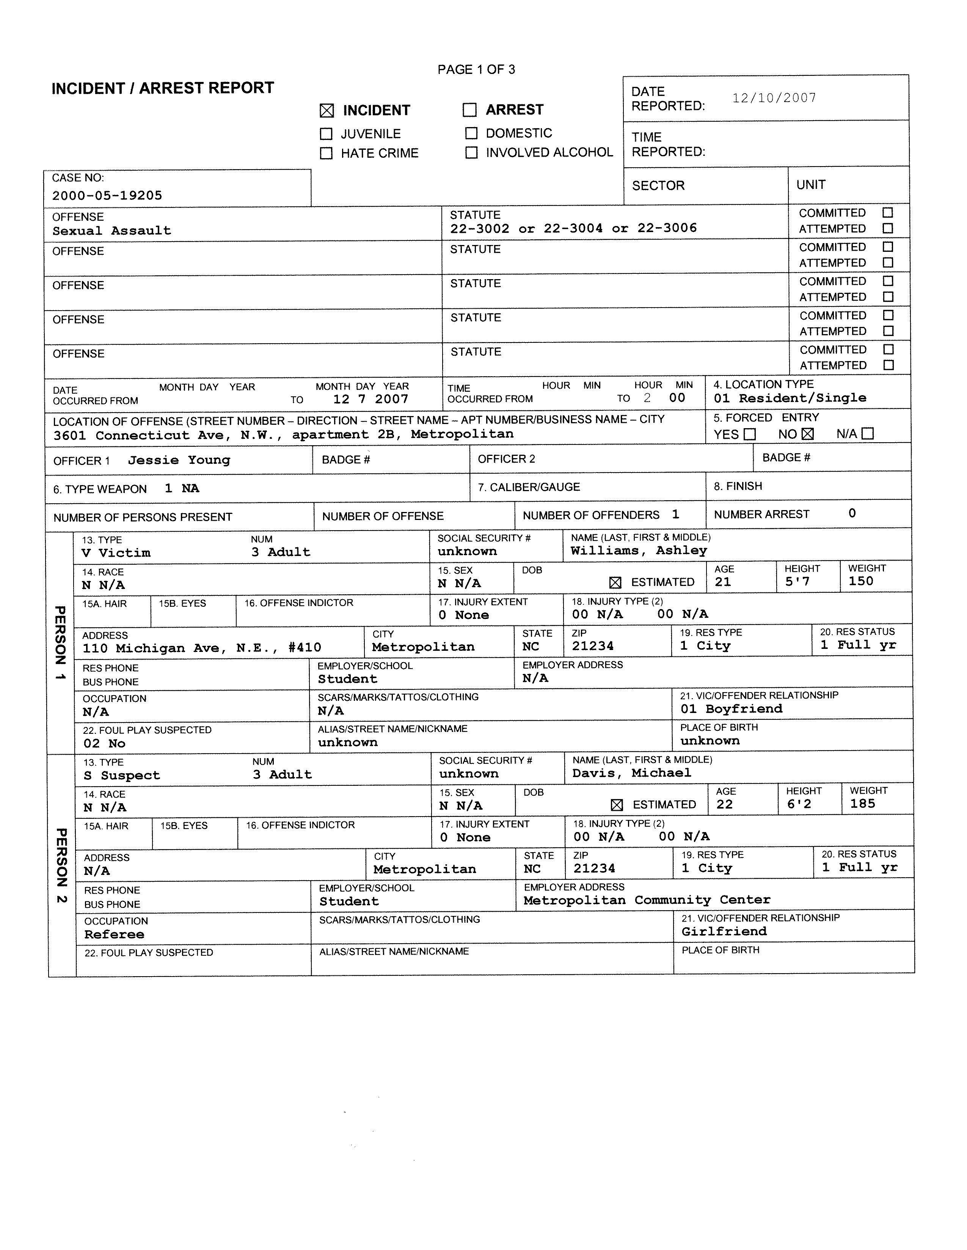

Page 38 of 59 US v. Davis
DC Street Law Clinic Georgetown Univeristy Law Center

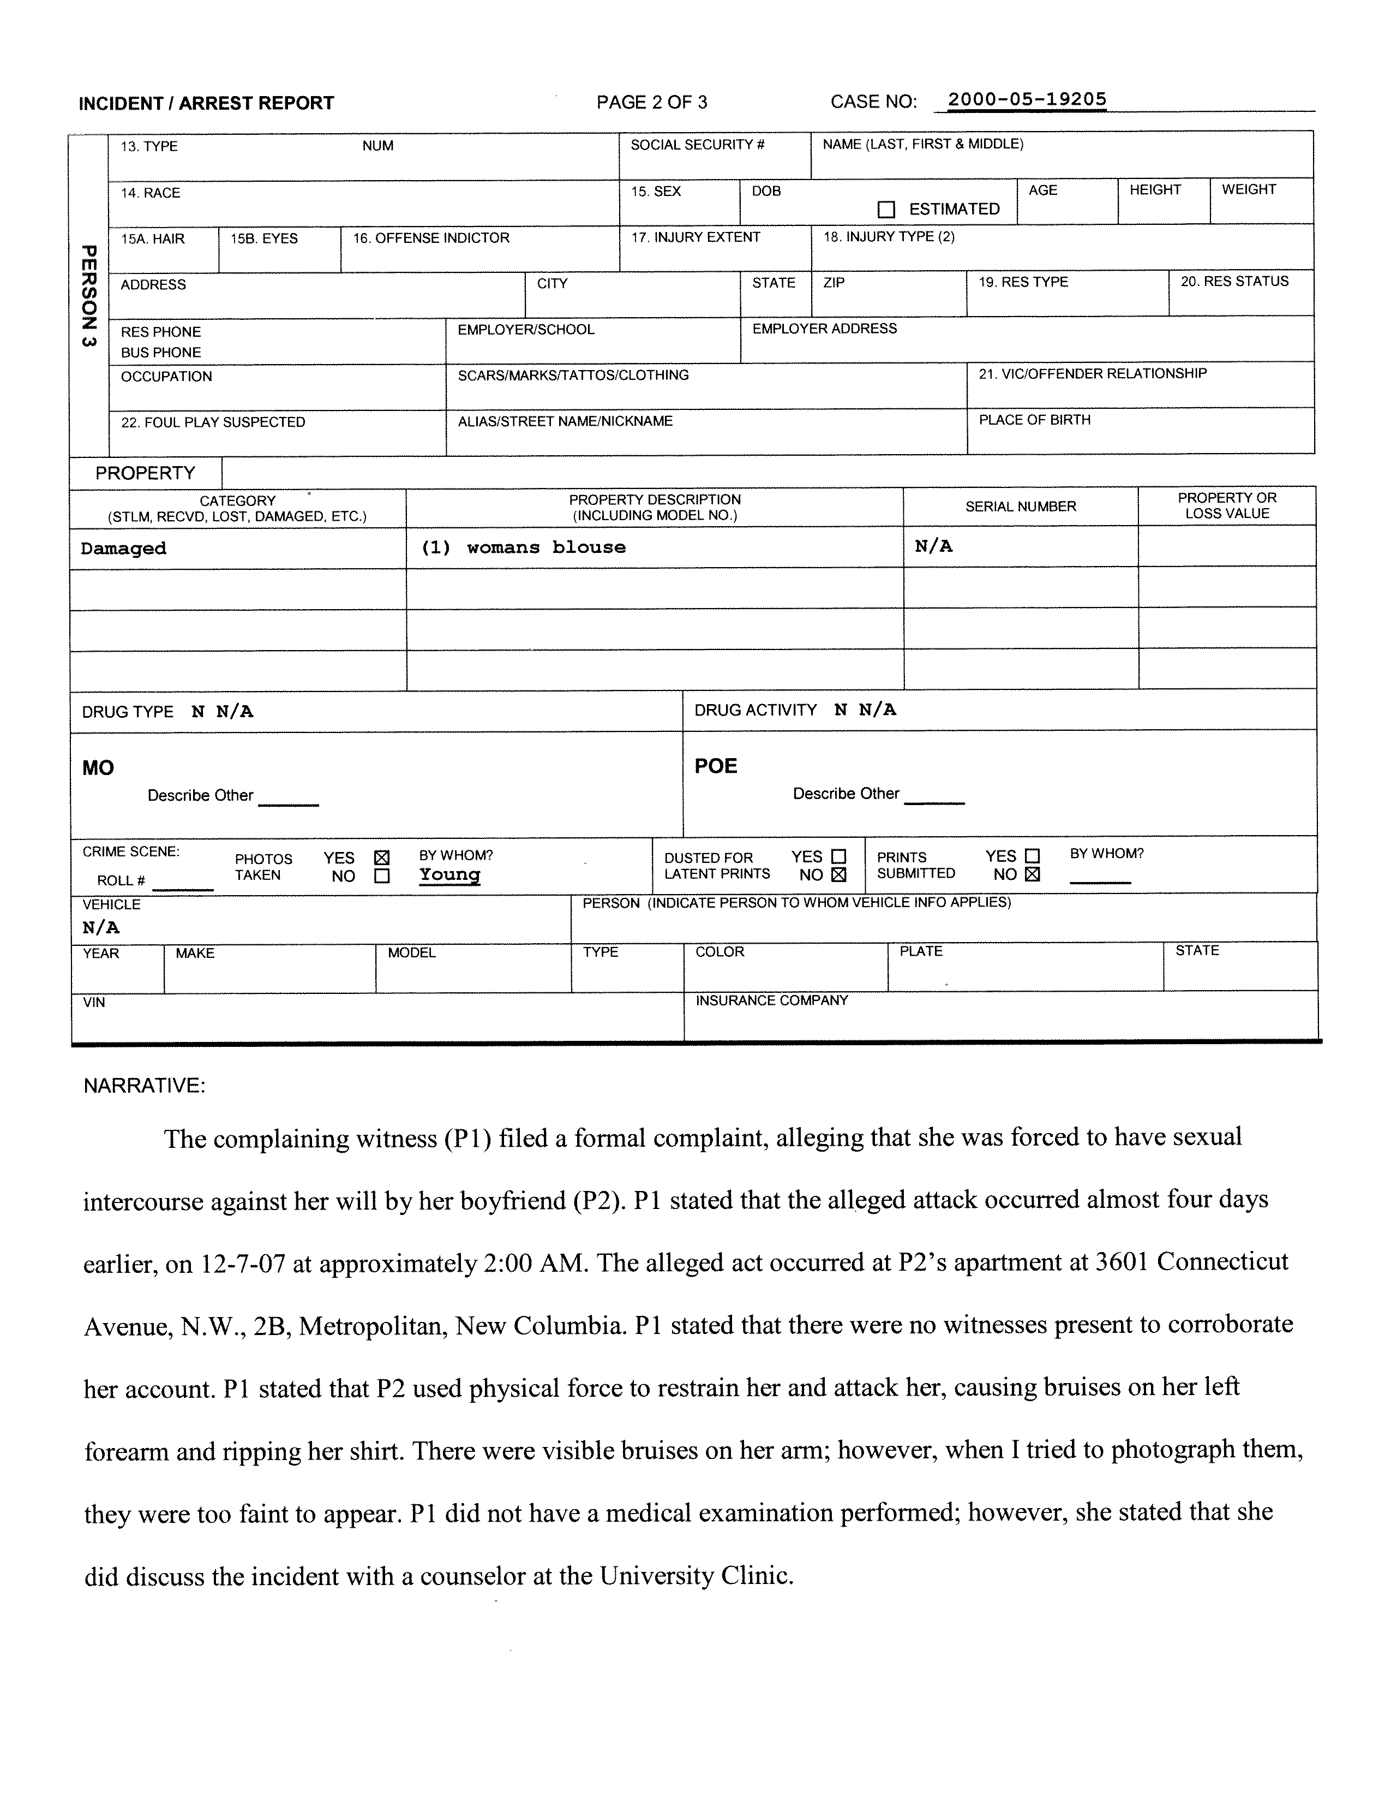

Page 39 of 59 US v. Davis
DC Street Law Clinic Georgetown Univeristy Law Center

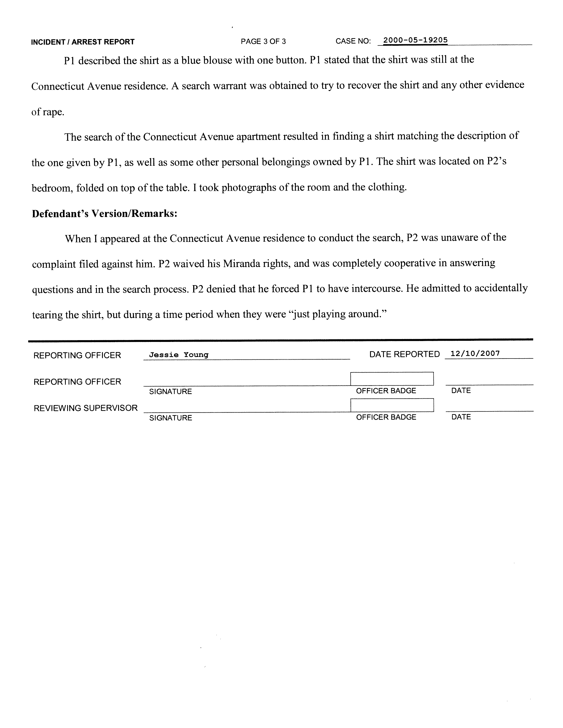

Page 40 of 59 US v. Davis
DC Street Law Clinic Georgetown Univeristy Law Center

[This Page Intentionally Left Blank]

Diary of Ashley Williams

November 4th ‘07

It was my birthday yesterday. I had a great day! First Mom and Dad sent me some flowers and a check for $100. Pat gave me a gorgeous light blue blouse. But the best part of the day was the time I spent with Michael. Since we’ve been back together, everything is going better than ever. He’s been so sweet and understanding. I know it’s been hard for him at times – we’ve come so close to sleeping together but I keep making him stop. He’s been really patient.
Last night was so romantic. Michael took me to a nearby city for dinner and he gave me a red rose. Then after dinner we took a walk down by the water – it was pretty warm out. He handed me a teddy bear, and it was so cute. I thought that was my present, but the bear had a gold chain around its neck. It’s beautiful. I’ll never take it off! I was so swept away by everything that by the time we got back to his place, I didn’t want to say no. (It’s a good thing I bought some condoms before because I don’t think he expected for things to happen so he wasn’t prepared.) This was the first time we made love since we got back together. Even though I told myself I wouldn’t until I was absolutely sure it was right. I couldn’t help myself. I hope he doesn’t expect it to happen again, though, because I’m not sure I want it to.

November 27th ‘07

Michael and I had a big fight last night. I was at his place hanging out, but when we started getting close, I said no but he didn’t take me seriously. Sometimes when I say no he stops right away, but other times I really have to get mad before he’ll stop. This was the worst it’s been so far. I actually had to leave for him to understand that I meant it. I was really upset, and was thinking that maybe I shouldn’t spend time over there anymore, but then he called this morning

and apologized. I told him I wasn’t going to spend time over there if it was going to cause problems, but he said that he didn’t’ want that to happen and that he was sorry. I guess I’ll have to wait and see what happens and if he really means it.

December 7th ‘07

Last night was the worst night of my life. I’m so upset right now I don’t know what to do.

Everything started out fine – Michael and I went to a party and had a great time. When we got back to his place, things started to happen, but when I tried to stop him, he wouldn’t listen. I told him “no” and I meant it. Every time I said “no” before he always stopped. I don’t know why he didn’t this time. He didn’t even stop when I started to cry.
I’m so angry, but I love Michael. Maybe I’m being unfair. No, it’s my body. I’m allowed to say no. I wanted to explain things to him, but I couldn’t get the words out. Then he actually accused me of being jealous over some dumb note! That really pissed me off. I had to get out of there, but he wouldn’t let me leave. I had my shirt in my hand and he grabbed it and ripped it. I loved that shirt – it’s the one Pat gave me for my birthday.
Pat says I should talk to a counselor and to the police. She says what Michael did was rape. I can’t believe it! I wish I could pretend that none of this ever happened, but I can’t. I just don’t know what to do.

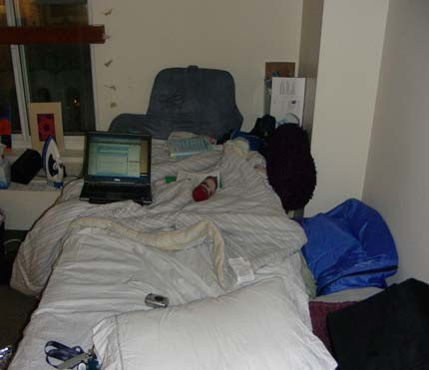
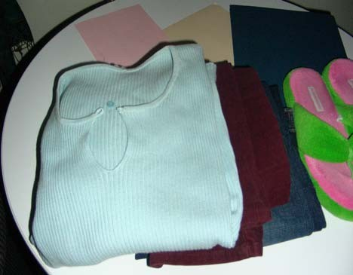
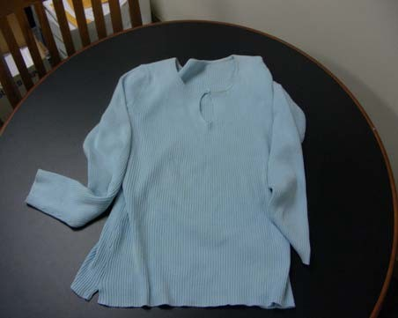
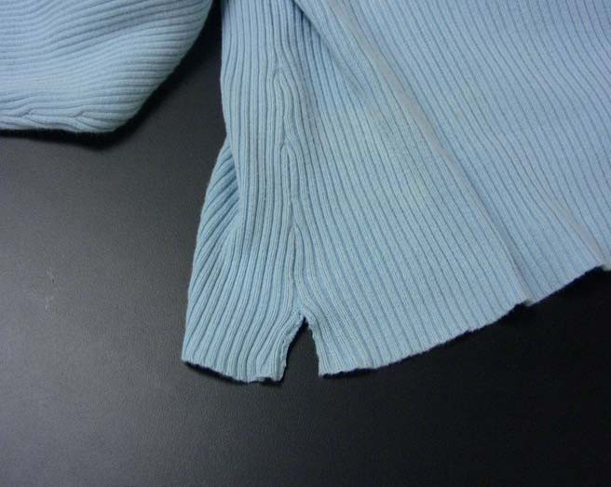

[This Page Intentionally Left Blank]

2009 MOCK TRIAL TOURNAMENT RULES

The annual Mock Trial Tournament is governed by the rules set forth below. These rules are designed to ensure excellence in presentation and fairness in judging all trials.

TEAM PRESENTATIONS

- The official mock trial materials, consisting of the Statement of Stipulated Facts, Witness Statements, Relevant Statutes and Case Law, and Pieces of Evidence, comprise the sole source of information for testimony. The Stipulated Facts and any additional stipulations may not be disputed at trial.
- Each witness is bound by the facts in the given witness statement. All participants agree that the witness statements are signed and sworn affidavits. Witness Statements may not be introduced as evidence, but may be used for impeachment.
Fair additions which (a) are consistent with facts contained in the witness affidavits and (b) do not materially give an advantage to the testifying party are permitted. If a witness is asked a question on cross-examination which is not dealt with in the witness's statement, the witness may invent an answer favorable to that witness's position.
Students may read other cases, materials, or articles in preparation for the mock trial. However, they may only cite the materials given, and they may only introduce into evidence those documents given in the official mock trial packet.
- If a witness testifies in contradiction of a fact in the witness statement during direct examination, there is no objection for “violating the rules of the mock trial.” The opposition must show the contradiction on cross-examination through correct use of the affidavit for impeachment. If a witness testifies in contradiction of a fact on cross-examination, the cross examining attorney should show the contradiction through impeachment also. This procedure is spelled out in the Simplified Rules of Evidence.
- If on direct examination witness invents an answer which is likely to affect the outcome of the trial, the opposition should show this on cross-examination through correct use of the affidavit for impeachment. This procedure is spelled out in the Simplified Rules of Evidence. The scorers should consider such inventions of facts in scoring the witness’ presentation.
- Witnesses are not permitted to use notes in testifying during the trial.

- All participants are expected to display proper courtroom decorum and collegial sportsmanlike conduct. The decisions of the judges with regard to rules challenges and all other decisions are final.
- The trial proceedings are governed by the Simplified Rules of Evidence. Other more complex rules may not be raised in the trial.
- During the actual trial, teachers, attorneys, other coaches, affiliated non-participating team members, parents and all other observers may not talk to, signal, or otherwise communicate with

or coach their teams. Team members may communicate with each other during the trial. Instructors from opposing teams are advised to sit next to one another, if possible, and be reasonable. The purpose of this rule is to prevent last minute coaching; it is not intended as a device to disqualify an opposing team.
- Neither team may introduce surprise witnesses nor call witnesses from the other side. All witnesses (three for each side) must take the stand, in whatever order or sequence determined by the party calling them.
- Witnesses will not be excluded from the courtroom during the trial.

- All teams in the tournament must consist of from three to eight attorneys, and three witnesses. Exceptions may be made by the D.C. Street Law Clinic after consultation.
- Only students registered in their high school for the Street Law class as of February 07, 2009 will be eligible to participate in the Mock Trial Tournament unless otherwise approved by the Director.
- Teams are expected to be present at the Superior Court for the District of Columbia by 5:30 p.m. the days of the trials. Trials will begin at 6 p.m.
- The starting time of any trial will not be delayed for longer than 15 minutes. Incomplete teams will have to begin without their other members, or with alternates.

JUDGING

- Presiding judges for the mock trials may include Judges and Commissioners of the District of Columbia, law school faculty, members of the D.C. Bar, other attorneys, or others approved by the Director.
- All judges receive the Guidelines for Judges, Judge’s Score Sheet, the Simplified Rules of Evidence, and the Mock Trial Packet.
- Presiding judges are asked to make a legal decision on the merits of the case, but this does not affect a team’s score. The decision on team scores is made by a scoring panel, consisting of two or more scorers selected by the Street Law Staff and, in some instances, the presiding judge. The criteria for scoring are discussed in the Guidelines for Scorers and the Score Sheet.
- All decisions of the judges are final.

[This Page Intentionally Left Blank]

SIMPLIFIED RULES OF EVIDENCE

To assure each side a fair trial, certain rules have been developed to govern the types of evidence that may be introduced, as well as the manner in which evidence may be presented. These rules are called the "rules of evidence." The attorneys and the judge are responsible for enforcing these rules. Before the judge can apply a rule of evidence, an attorney must ask the judge to do so. Attorneys do this by making "objections" to the evidence or procedure employed by the opposing side. When an objection is raised, the attorney who asked the question that is being challenged will usually be asked by the judge why the question was not in violation of the rules of evidence.
The rules of evidence used in real trials can be very complicated. A few of the most important rules of evidence have been adapted for mock trial purposes, and these are presented below.

Rule 1. Leading Questions:
A "leading" question is one that suggests the answer desired by the questioner, usually by stating some facts not previously discussed and then asking the witness to give a yes or no answer.
Example: "So, Mr. Smith, you took Ms. Davis to a movie that night, didn't you?"

Leading questions may not be asked on direct or redirect examination. Leading questions may be used on cross-examination.
Objection: "Objection, Your Honor, counsel is leading the witness."

Possible Response: "Your Honor, leading is permissible on cross-examination," or "I'll rephrase the question." For example, the question can be rephrased: "Mr. Smith, where did you go that night? With whom did you go to the movies?" (This would not suggest the answer the attorney desires.)

Rule 2. Narration:
Narration occurs when the witness provides more information than the question called for.

Example: Question - "What did you do when you reached the front door of the house?"

Witness - "I opened the door and walked into the kitchen. I was afraid that he was in the house -- you know, he had been acting quite strangely the day before."
Witnesses' answers must respond to the questions. A narrative answer is objectionable.

Objection: "Objection, Your Honor, the witness is narrating."

Response: "Your Honor, the witness is telling us a complete sequence of events."

Rule 3. Relevance:

Questions and answers must relate to the subject matter of the case; this is called "relevance." Questions or answers that do not relate to the case are "irrelevant."
Example: (In a traffic accident case) "Mrs. Smith, how many times have you been married?"

Irrelevant questions or answers are objectionable.

Objection: "Your Honor, this question is irrelevant to this case."

Response: "Your Honor, this series of questions will show that Mrs. Smith's first husband was killed in an auto accident, and this fact has increased her mental suffering in this case."

Rule 4. Hearsay:
"Hearsay" is something the witness has heard someone say outside the courtroom. Also, any written statement made outside the courtroom is hearsay.
Example: "Harry told me that he was going to visit Mr. Brown."

Hearsay evidence is objectionable. However, there are two exceptions to the hearsay rule for purposes of the mock trial. If an exception applies, the court will allow hearsay evidence to be introduced. Exception: In a mock trial, hearsay evidence is allowed when the witness is repeating a statement made directly to the witness by one of the witnesses in the case. Hearsay is also allowed if one of the witnesses is repeating a statement made by an individual who is no longer alive.
Note that this exception to the hearsay rule does not extend to witness testimony about what another person heard a witness say. This is "double hearsay."
Example: Mary, the plaintiff, told me that Harry, the defendant was drunk the night of the accident.

Objection: "Objection, Your Honor, this is double hearsay."

Response: "Your Honor, since Harry is the defendant, the witness can testify to a statement he heard Harry make."
For mock trials, other exceptions to the hearsay rule are not used.

Rule 5. Firsthand Knowledge:
Witnesses must have directly seen, heard, or experienced whatever it is they are testifying about. A lack of firsthand knowledge is objectionable.
Example: "I saw Harry drink two beers that night. I know Harry well enough to know that two beers usually make him drunk, and he seemed drunk that night, too."

Objection: "Your Honor, the witness has no firsthand knowledge of Harry's condition that night."

Response: "The witness is just generally describing her usual and actual experience with Harry."

Rule 6. Opinions:
Unless a witness is qualified as an expert in the appropriate field, such as medicine or ballistics, the witness may not give an opinion about matters relating to that field. Opinions are objectionable unless given by an expert qualified in the appropriate field.
Example: (Said by a witness who is not a doctor) "The doctor put my cast on wrong. That's why I have a limp now."
Objection: "Objection, Your Honor, the witness is giving an opinion."

Response: "Your Honor, the witness may answer the question because ordinary persons can judge whether a cast was put on correctly."
Ruling: A judge will likely sustain this objection because it may not be within an ordinary person’s knowledge to know whether an incorrectly placed cast will cause a limp.
As an exception to this rule, a lay witness may give an opinion based on common experience.

Example: "It looked to me like Harry was drunk that night. I’ve seen him drunk and have seen other drunks before.”
Objection: "Objection, Your Honor, the witness is giving an opinion."

Response: "Your Honor, the witness may answer the question because ordinary persons may judge whether or not a person appeared drunk based on the witness’ experience."

Rule 7. Opinions on the Ultimate Issue:
Witnesses, including experts, cannot give opinions on the ultimate issue of the case: the guilt or innocence of the defendant or the liability of the parties. These are matters for the trier of fact to decide.
Example: "I believe that Mr. Smith was negligent in driving too fast in this case."

Opinions on the ultimate issue in a case are objectionable.

Objection: "Your Honor, the witness is giving an opinion on the ultimate issue – the negligence of Mr. Smith."

Response: "The witness is commenting that the driver was speeding. This is not the ultimate issue in this case."

Rule 8. Additional Rules of Evidence:
  - Objections during the testimony of a witness must be made only by the direct examining and cross-examining attorneys for that witness.
  - Cross-examination is not limited to the scope of direct questioning.

  - A short redirect examination, limited to no more than two questions, will be allowed following cross-examination, if an attorney desires. Questions on redirection are limited to the scope of the cross-examination.
  - If an attorney (on direct or cross-examination) repeatedly asks a witness to discuss the exact same matter, opposing counsel may object to the question as being “asked and answered.” It is in the court’s interest to have the trial move along in a timely manner.
  - Witnesses must be treated with respect by opposing counsel. If an attorney continuously, and for no valid trial or evidentiary purpose, takes a disrespectful tone with the witness, the opposing counsel may object that the questioning attorney is “badgering the witness.”

Rule 9. Special Procedures:
Procedure 1. Introduction of Documents or Physical Evidence:

Sometimes the parties wish to offer as evidence letters, affidavits, contracts, or other documents, or even physical evidence such as a murder weapon, broken consumer goods, etc. Special procedures must be followed before these items can be used in trial.
Step 1: Introducing the Item for Identification

    - An attorney says to the judge, "Your Honor, I wish to have this (letter, document, item) marked for identification as (Plaintiff's Exhibit A, Defense Exhibit 1, etc.)."
    - The attorney takes the item to the clerk, who marks it appropriately.

    - The attorney shows the item to the opposing counsel.

    - The attorney shows the item to the witness and says, "Do you recognize this item marked as Plaintiff's Exhibit A?"
Witness: "Yes."

Attorney: "Can you please identify this item?"

Witness: "This is a letter I wrote to John Doe on September 1." (Or witness gives other appropriate identification.)
    - The attorney may then proceed to ask the witness questions about the document or item.

Step 2. Moving the Document or Item into Evidence.

If the attorney wishes the judge or jury to consider the document or item itself as part of the evidence and not just as testimony about it, the attorney must ask to move the item into evidence at the end of the witness examination. The attorney proceeds as follows:
- The attorney says, "Your Honor, I offer this (document/item) into evidence as Plaintiff's Exhibit A, and ask that the court so admit it."
- Opposing counsel may look at the evidence and make objections at this time.
- The judge rules on whether the item may be admitted into evidence.

Procedure 2. Impeachment

On cross-examination, an attorney wants to show that the witness should not be believed. This is best accomplished through a process called "impeachment," which may use one of the following tactics: (1) asking questions about prior conduct of the witness that makes the witness' truthfulness doubtful (e.g., "Isn't it true that you once lost a job because you falsified expense reports?"); (2) asking about evidence of certain types of criminal convictions (e.g., "You were convicted of shoplifting, weren't you?"); or (3) showing that the witness has contradicted a prior statement, particularly one made by the witness in an affidavit. Witness statements in the Mock Trials Materials are considered to be affidavits.
In order to impeach the witness by comparing information in the affidavit to the witness' testimony, attorneys should use this procedure:
Step 1: Repeat the statement the witness made on direct or cross-examination that contradicts the affidavit.
Example: "Now, Mrs. Burke, on direct examination you testified that you were out of town on the night in question, didn't you?" (Witness responds, "Yes.")
Step 2: Introduce the affidavit for identification, using the procedure described in Procedure 1.

Step 3: Ask the witness to read from his or her affidavit the part that contradicts the statement made on direct examination.
Example: "All right, Mrs. Burke, will you read paragraph three?" (Witness reads, "Harry and I decided to stay in town and go to the theater.")
Step 4: Dramatize the conflict in the statements. (Remember, the point of this line of questioning is to demonstrate the contradiction in the statements, not to determine whether Mrs. Burke was in town or out of town.)

Example: "So, Mrs. Burke, you testified that you were out of town on the night in question, didn't you?" "Yes." "Yet, in your affidavit you said you were in town, didn't you?" "Yes."

Note: For an impeachment for a contradictory prior statement, the point is that because the witness has made two contradictory statements about a matter, the witness may not be believable on that matter. The contradiction also may cast doubt on the witness’ truthfulness, generally.
Impeachment does NOT disprove a statement; it only casts doubt on either statement.

Procedure 3. Qualifying an Expert
Only a witness who is qualified as an expert may give an opinion as to scientific, technical, or other specialized knowledge in the area of his/her expertise. (Note: A lay witness may give an opinion about something related to one's common experience (see Rule 6). Experts cannot give opinions on the ultimate issue of the case.
Before an expert gives his/her expert opinion on a matter, the lawyer must first qualify the expert. There are two steps to qualify an expert. First, the lawyer must lay a foundation that shows the expert is qualified to testify on issues related to that expert's field of expertise. To lay a foundation, the lawyer asks the expert to describe factors such as schooling, professional training, work experience and books he/she has written that make a person an expert regarding a particular field. Second, once the witness has testified about his/her qualifications, the lawyer asks the judge to qualify the witness as an expert in a particular field.
Example: The wife of Harold Hart is suing Dr. Smith and General Hospital for malpractice. She claims they did not treat Mr. Hart for an obvious heart attack when he was brought to the hospital. Mrs. Hart's lawyer is examining his expert witness, Dr. Davis:
Q: Dr. Davis, what is your occupation?

A: I am a heart surgeon. I am Chief of Staff at the Howard University Medical Center. Q: What medical school did you attend?
A: I graduated from Georgetown Medical School in 1978. Q: Where did you do your internship?
A: I did a two-year internship in cardiology at John Hopkins University from 1978-1980. Q: Did you afterwards specialize in any particular field of medicine?
A: Yes, I specialized in heart attack treatment and heart surgery. Q: Have you published any articles or books?
A: I wrote a chapter in a medical text on heart surgery procedures after heart attacks. Q: Describe the chapter.
A: I set out the steps for identifying heart attacks and doing open heart surgery.

Q: What professional licenses do you have?

A: I am certified by the D.C. Board of Medical Examiners to practice medicine in D.C. Attorney #1: Your Honor, I ask that Dr. Davis be qualified as an expert in the field of medicine. Judge: Any objection?
Attorney #2: We object. No foundation has been laid regarding Dr. Davis's ability to render an opinion as to all fields of medicine.
Judge: Objection sustained. Dr. Davis's expertise seems to be limited to certain areas of medicine.

Attorney #1: Thank you, your Honor. We ask that Dr. Davis be qualified as an expert in the field of heart surgery.
Judge: Any objections? Attorney #2: No, your Honor.
Judge: Let the record reflect that Dr. Davis is qualified to testify as an expert in the field of heart surgery.
Once qualified, an expert may give opinions relating only to the expert's area of expertise. That is, an expert cannot give an opinion in an area outside his/her expertise.
Example: (Dr. Davis has been qualified as an expert on heart surgery.) Q: Dr. Davis, what is your opinion as to Mr. Hart's cause of death?
A: The patient suffered a massive heart attack caused by clogged arteries.

Q: Dr. Davis, in your opinion, is it true as the defense contends that the patient also suffering from a rare lung disease transmitted through contact with the North American mongoose as the defense contends?
Objection: The witness is testifying outside her area of expertise.
Judge: Sustained. Please confine your opinion to matters related to care and treatment of the heart.
Q: Dr. Davis, in your opinion, how should the patient's doctors have treated him?

A: They should have recognized that the patient was having a heart attack based on his chest pains, purple face, difficulty breathing, and numbness in his left arm. They should have given him the proper medication and treated him in the emergency room right away.
Q: Who was at fault in this matter?
A: Dr. Smith and General Hospital were definitely negligent.

Objection: The witness is testifying to the ultimate issue of the case, which is whether Dr. Smith and General Hospital are liable for malpractice. That is a question of fact for the judge (or jury, when the case is tried before a jury) to decide.
Judge: Sustained.

Special Thanks to:

Algie Said Jacqueline Smith Chris Difo
Tori Gordon Aja Sae-Kung Jadine Johnson Wiline Justilien Ande Durojaiye
National Institute for Citizen Education in the Law Street Law Inc.,
The Students of the DC Street Law Clinic

Minuteman Press

