On the Brink of War - Cold War Culture
 | 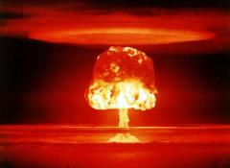 | 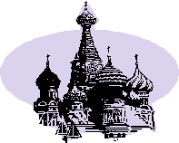

Introduction
• The Cold War between the United States and Soviet Union was a powder keg waiting to explode. Both countries were teetering on the edge of a war that could turn “hot” at any moment. From 1945-1991, these two superpowers fought an economic, social, and philosophical war that could have erupted into a nuclear war with unfathomable destructive capabilities.
• You will explore how the Cold War affected U.S. culture.
• How important was the Cold War in the daily lives of Americans? To what extent did it invade the U.S. national psyche?

The Task
• With your partner, you will find FIVE examples (one from each category) of the effect of the Cold War on American culture. Choose from the following categories:
- Find a song or movie that reflects the fear, patriotism, and/or competition between the Soviets and the Americans.
- Find a television show or episode of a television show that reflects the fear, patriotism, and/or competition between the Soviets and the Americans.
- Find a public service announcement/advertisement/propaganda directing Americans what to do in the event of a nuclear emergency.
- Find a sporting event that was affected by the Cold War.
- Find an example of literature (poem or prose) written during the Cold War.
• After you find your five examples, you and your partner will create a power point presentation.

Process
• Find your five examples. Choose the examples that are of most interest to you.
• Explore these examples further (e.g., for a television show, find out background information about the show and any evidence that this show reflects cold war culture.)
• Once you have your examples along with the necessary information, create a power point presentation. This should highlight your five examples and include an explanation of how your examples reflect the culture of this time period.

Resources
• Use the following websites:
- http://www.coldwar.org/
- http://www.conelrad.com/
- http://en.wikipedia.org/wiki/Culture_during_the_Cold_War
- http://alphahistory.com/coldwar/cold-war-music/
- http://dailycaller.com/2014/03/14/top-10-greatest-cold-war-movies-slideshow/
- http://jfredmacdonald.com/trm/111coldwartv.htm
- http://manspropaganda.wordpress.com/the-cold-war/
- http://www.pbs.org/wnet/secrets/the-cold-war-sporting-front/53/
- http://io9.com/5401874/the-cold-war-in-science-fiction

• The above websites will help you in your search but do not limit yourself to these sites.

Conclusion
• The Cold War was an event in history that invaded every facet of lives all over the world for nearly fifty years. Not only did it affect every foreign policy decision U.S. presidents made between 1945-1991, it also became a part of everyday American life.
• Through this Web Quest, you have seen the extent to which this is true.

Credits and References
• List all the sources you used at the end of your power point presentation.

